VIETNAM GENERAL CONFEDERATION OF LABOR

**TON DUC THANG UNIVERSITY**

**FACULTY OF INFORMATION TECHNOLOGY**



**FINAL PROJECT FOR SOFTWARE ENGINEERING**

**Coffee Management System**

*Instructor*: **Mr. NGUYEN NGOC PHIEN**

*Authors*: **NGUYEN HUYNH ANH KHOA – 522H0046**

**PHAM DUY BAO - 522H0063**

**TRAN GIA HAO – 522H0080**

**TONG NGUYEN GIA HUY – 522H0077**

**PHAM DUY KHANH – 522H0064**

Class **: 502045**

Course  **: 26**

**HO CHI MINH CITY, YEAR 2024**

VIETNAM GENERAL CONFEDERATION OF LABOR

**TON DUC THANG UNIVERSITY**

**FACULTY OF INFORMATION TECHNOLOGY**



**FINAL PROJECT FOR SOFTWARE ENGINEERING**

**Coffee Management System**

*Instructor*: **Mr. NGUYEN NGOC PHIEN**

*Authors*: **NGUYEN HUYNH ANH KHOA – 522H0046**

**PHAM DUY BAO - 522H0063**

**TRAN GIA HAO – 522H0080**

**TONG NGUYEN GIA HUY – 522H0077**

**PHAM DUY KHANH – 522H0064**

Class **: 502045**

Course  **: 26**

**HO CHI MINH CITY, YEAR 2024**

ACKNOWLEDGEMENT

First of all, we would like to express our gratitude to Mr. Nguyen Ngoc Phien for his patient instruction and guidance, which allowed us to finish the report with little difficulty in terms of our expertise.

Next, we would like to thank each and every one of the distinguished professors at Ton Duc Thang University's Faculty of Information Technology for their contributions, expertise, and encouragement as we worked to complete the essay and further our education.

**PROJECT COMPLETED**

**AT TON DUC THANG UNIVERSITY**

We hereby certify that this is our own project product and was guided by Mr. Nguyen Ngoc Phien. The research content and results in this topic are truthful and have not been previously published in any form. The data in the tables serve for analysis, comments, evaluation, and were collected by the author from various sources, clearly indicated in the reference section.

Additionally, in the project, there are also comments, evaluations, and data from other authors and organizations, all properly cited and referenced.

**If any form of academic dishonesty is discovered, we take full responsibility for the content of our project.** Ton Duc Thang University is not liable for any copyright infringement or violation caused by me during the implementation process (if any).

*Ho Chi Minh city, date month year*

*Authors*

*(Sign and write full name)*

*Nguyen Huynh Anh Khoa*

*Pham Duy Bao*

*Tong Nguyen Gia Huy*

*Pham Duy Khanh*

*Tran Gia Hao*

TEACHER'S CONFIRMATION AND ASSESSMENT

SECTION

**The confirmation part of the instructor**

_______________________________________________________________________________________________________________________________________________________________________________________________________________________________________________________________________________________________________________________________________________________________________________________________________________

Ho Chi Minh city, date month year

(Sign and write full name)

**The evaluation part of the teacher marks the test** _______________________________________________________________________________________________________________________________________________________________________________________________________________________________________________________________________________________________________________________________________________________________________________________________________________

Ho Chi Minh city, date month year

(Sign and write fullname)

SUMMARY

Software for managing coffee shops is a comprehensive suite designed to operate traditional coffee shops without the assistance of an information system. All forms of traditional coffee shop administration require a few fundamental requirements in order to regulate customer-leased systems and process payments on time. For the cashier to use at the counter for a set period of time, an old-fashioned coffee shop often contains at least one computer. These days, having a separate management software can assist traditional retailers track company statistics more rapidly, save the cost of obtaining payment systems with different devices, and facilitate faster client interaction. As a result, there will be fewer employees working at the counter, and possibly require just enough staff to avoid spending a large amount of money on payroll.

TABLE OF CONTENTS

ACKNOWLEDGEMENT i

TEACHER'S CONFIRMATION AND ASSESSMENT iii

SECTION iii

SUMMARY iv

TABLE OF CONTENTS 1

TABLES OF FIGURES AND TABLES 3

CHAPTER 1: INTRODUCTION 9

1.1 Purpose and scope 9

1.2 Product interview 9

CHAPTER 2: PROJECT MANAGEMENT PLAN 11

2.1 Project organization 11

2.2 Lifecycle Model Used 11

2.2.1 Definition 11

2.2.2 Model phases 12

12

2.2.3 Advantages 14

2.2.4 Disadvantages 14

2.2.5 Risk analysis 15

CHAPTER 3: REQUIREMENT SPECIFICATIONS 17

1. Stakeholders for the system 17

a. Internal stakeholders: 17

b. External stakeholders: 17

2. Use case model 18

i. Use case diagrams model 18

ii. Textual description for each use case 27

iii. Activity diagrams model 53

3. Functional requirements 104

4. Non-functional requirements 105

CHAPTER 4: TECHNOLOGY IS USED 105

4.1 Programming language: Java (Jframe GUI) 105

4.2 Architecture: JFC/Swing component architecture 105

4.3 Software: Apache Netbeans compiler 106

4.4 Source code management: Git 106

4.5 Architectural model: UML (Unified Modeling Language) 107

CHAPTER 5: DESIGN 109

1. Database Design 109

a. Data flow diagrams (DFDs) 109

b. Data dictionaries 110

c. Entity-relationship diagram 111

d. Relationship Schema 111

e. Table design 112

2. Static model – class diagram 113

CHAPTER 6: DEMO CODE 113

1. Manager interface 113

2. Staff interface 119

CHAPTER 7: TEST PLAN 120

1. Requirements system level test cases 120

2. Requirements system level test cases 120

3. Test results 121

TABLES OF FIGURES AND TABLES

**TABLE OF FIGURES**

Figure 1: Project Organization 11

Figure 2: Waterfall model 12

Figure 3: General use case diagram 19

Figure 4: Log in decomposition use case diagram 19

Figure 5: Sign up decomposition use case diagram 20

Figure 6: Forgot password decomposition use case diagram 21

Figure 7: Add new product decomposition use case diagram 22

Figure 8: Manage category decomposition use case diagram 23

Figure 9: Manage product decomposition use case diagram 24

Figure 10: Manage user decomposition use case diagram 25

Figure 11: Place order decomposition use case diagram 26

Figure 12: Update account’s information decomposition use case diagram 27

Figure 13: Log in activity diagram 54

Figure 14: Sign up activity diagram 55

Figure 15: Log out activity diagram 55

Figure 16: Forgot password activity diagram 56

Figure 17: Update account’s information activity diagram 57

Figure 18: Change security question activity diagram 58

Figure 19: Change password activity diagram 59

Figure 20: Place order activity diagram 60

Figure 21: Place order - Add to cart activity diagram 61

Figure 22: Place order – Pay activity diagram 62

Figure 23: Place order – Generate bill activity diagram 63

Figure 24: Place order – Add customer’s details activity diagram 63

Figure 25: View bill’s details activity diagram 64

Figure 26: View bill’s details – View PDF bill activity diagram 65

Figure 27: View bill’s details – Print bill activity diagram 66

Figure 28: View bill’s details – View activity diagram 66

Figure 29: View bill’s details – Order by date activity diagram 67

Figure 30: View bill’s details – Order by user ID activity diagram 67

Figure 31: Manage category activity diagram 68

Figure 32: Manage category – Add activity diagram 69

Figure 33: Manage category – View activity diagram 69

Figure 34: Manage category – Delete activity diagram 70

Figure 35: Add new product activity diagram 71

Figure 36: Manage product activity diagram 72

Figure 37: Manage product – View activity diagram 72

Figure 38: Manage product – Edit activity diagram 73

Figure 39: Manage product – Delete activity diagram 74

Figure 40: Manage user activity diagram 75

Figure 41: Manage user – Search request activity diagram 76

Figure 42: Manage user – View manage user activity diagram 76

Figure 43: Manage user – Change status activity diagram 77

Figure 44: Clear activity diagram 78

Figure 45: Exit activity diagram 78

Figure 46: Place order – Remove activity diagram 79

Figure 47: Log in sequence diagram 80

Figure 48: Sign up sequence diagram 81

Figure 49: Log out sequence diagram 82

Figure 50: Forgot password sequence diagram 84

Figure 51: Update account sequence diagram 84

Figure 52: Change security question sequence diagram 85

Figure 53: Change password sequence diagram 86

Figure 54: Place order sequence diagram 87

Figure 55: Place order – Add to cart sequence diagram 88

Figure 56: Place order – Pay sequence diagram 89

Figure 57: Place order – Generate bill sequence diagram 89

Figure 58: Place order – Add user’s details sequence diagram 90

Figure 59: View bill’s details sequence diagram 90

Figure 60: View bill’s details – View PDF bill sequence diagram 91

Figure 61: View bill’s details – Print bill sequence diagram 91

Figure 62: View bill ‘details – View sequence diagram 92

Figure 63: View bill’s details – Order by date sequence diagram 92

Figure 64: View bill’s details – Order by user ID sequence diagram 92

Figure 65: Manage category sequence diagram 93

Figure 66: Manage category – Add sequence diagram 94

Figure 67: View category sequence diagram 94

Figure 68: Manage category – Delete sequence diagram 95

Figure 69: Add new product sequence diagram 96

Figure 70: Manage product sequence diagram 97

Figure 71: View product sequence diagram 97

Figure 72: Edit product sequence diagram 98

Figure 73: Delete product sequence diagram 99

Figure 74: Manage user sequence diagram 100

Figure 75: Manage user – Search sequence diagram 101

Figure 76: View user sequence diagram 101

Figure 77: Manage user – Change status sequence diagram 102

Figure 78: Clear sequence diagram 102

Figure 79: Exit sequence diagram 103

Figure 80: Place order – Remove from cart sequence diagram 103

Figure 81: Data flow diagrams (DFDs) 109

Figure 82: Entity-relationship diagram 111

Figure 83: Relationship schema diagram 112

Figure 84: ‘User’ table 112

Figure 85: ‘Product’ table 112

Figure 86: ‘Category’ table 112

Figure 87: ‘Bill’ table 113

Figure 88: Class diagram 113

Figure 89: Main screen 114

Figure 90: Login screen 114

Figure 91: Signup screen 115

Figure 92: Change Security Question screen 115

Figure 93: Change Password screen 116

Figure 94: View Bill’s Detail screen 116

Figure 95: Place Order screen 117

Figure 96: Manage Users screen 117

Figure 97: Manage Product screen 118

Figure 98: New Product screen 118

Figure 99: Manage Category screen 119

Figure 100: Main screen 119

**TABLE OF TABLES**

Table 1: Actual interview table 10

Table 2: Risk analysis 17

Table 3: Actors and goals 18

Table 4: Use case description 1 28

Table 5: Use case description 2 29

Table 6: Use case description 3 29

Table 7: Use case description 4 30

Table 8: Use case description 5 31

Table 9: Use case description 6 32

Table 10: Use case description 7 32

Table 11: Use case description 8 33

Table 12: Use case description 9 34

Table 13: Use case description 10 35

Table 14: Use case description 11 35

Table 15: Use case description 12 36

Table 16: Use case description 13 37

Table 17: Use case description 14 38

Table 18: Use case description 15 38

Table 19: Use case description 16 39

Table 20: Use case description 17 40

Table 21: Use case description 18 41

Table 22: Use case description 19 41

Table 23: Use case description 20 42

Table 24: Use case description 21 43

Table 25: Use case description 22 44

Table 26: Use case description 23 45

Table 27: Use case description 24 45

Table 28: Use case description 25 46

Table 29: Use case description 26 47

Table 30: Use case description 27 48

Table 31: Use case description 28 48

Table 32: Use case description 29 49

Table 33: Use case description 30 50

Table 34: Use case description 31 51

Table 35: Use case description 32 51

Table 36: Use case description 33 52

Table 37: Use case description 34 53

Table 38: Functional requirements 105

Table 39: Non-functional requirements 105

Table 40: Apache Netbeans OS requirement 106

Table 41: Structure diagram in use 108

Table 42: Behavioral diagram in use 109

Table 43: Data dictionary for “user” table 111

Table 44: Test case and result. 126

CHAPTER 1: INTRODUCTION

* 1. Purpose and scope

Purpose:

The goal of this document is for use as a source of full details about the architecture of software, technology utilized, software data, analysis, and specifications for design.

The program was created as an economical and efficient management and business solution for the coffee industry.

Feasibility:

The coffee shop's management system was designed to help them organize staff and management processes and boost sales speed. Manage orders, customers, income, and costs well.

Technical feasibility: While Jframe-based software is one of the frameworks most frequently available today, problems are likely to be easily fixed and well-supported.

Operational feasibility: The program is created in Java and runs on an open-source system. It easy to use on all devices and needs only 12.2 MB of memory for storage.

Economic feasibility: This software will help cafe owners control the costs and profits in every day activities by save them money on operating costs and effort on income settlement, staff, invoice planning, and customer information management. To speed up the employment procedure.

Scope:

Software must satisfy the minimal standard of business, include managing employees, managing income and expenses, managing products and customer information.

* 1. Product interview

|  |  |  |  |  |
| --- | --- | --- | --- | --- |
| **Interviewer** | **Interviewees** | **Interviewee's role** | **Interview question** | **Answer** |
| Nguyễn Huỳnh Anh Khoa | Phạm Bảo Long | User | Have you ever used any café management software before? | Yes, I have used café management software before. |
| Nguyễn Huỳnh Anh Khoa | Lâm Phú Cường | User | Is the main page interface and job detail page designed to be simple, user-friendly, and easy to read? | Yes, both the main page interface and job detail page are designed to be simple, user-friendly, and easy to read. |
| Nguyễn Huỳnh Anh Khoa | Bùi Đoàn Minh Quân | User | Do the functions provided by the software meet all your needs? | Yes, the functions provided by the software meet all my needs. |
| Nguyễn Huỳnh Anh Khoa | Nguyễn Cao Kỳ | User | What features or functionalities would you consider essential in a café management software? | Inventory management, Employee management, and customer relationship management |
| Nguyễn Huỳnh Anh Khoa | Trần Minh Thư | User | What kind of reporting capabilities would be most valuable to you in monitoring your café's performance and making informed decisions? | Inventory reports, profit and loss statements, and employee performance |
| Nguyễn Huỳnh Anh Khoa | Võ Nhật Hào | User | What are your expectations regarding the software's ability to analyze sales data and provide insights to improve business performance? | Comprehensive analysis, data visualization, and customizable reports |

Table 1: Actual interview table

CHAPTER 2: PROJECT MANAGEMENT PLAN

* 1. Project organization

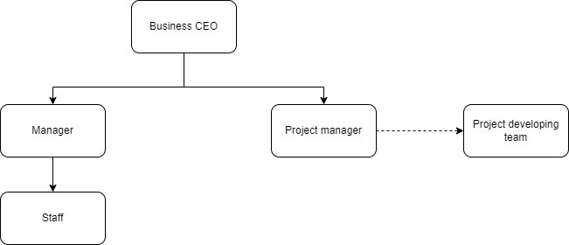

Figure 1: Project Organization

* 1. Lifecycle Model Used
     1. Definition

The classical waterfall model is the basic software development life cycle model. It is very simple but idealistic. Earlier this model was very popular but nowadays it is not used. But it is very important because all the other software development life cycle models are based on the classical waterfall model. The classical waterfall model divides the life cycle into a set of phases. This model considers that one phase can be started after the completion of the previous phase. That is the output of one phase will be the input to the next phase. Thus, the development process can be considered as a sequential flow in the waterfall.

* + 1. Model phases

Figure 2: Waterfall model

Feasibility study: The main goal of this phase is to determine whether it would be financially and technically feasible to develop the software. The feasibility study involves understanding the problem and then determining the various possible strategies to solve the problem.

Requirements analysis and specification: The aim of the requirement analysis and specification phase is to understand the exact requirements of the customer and document them properly. This phase consists of two different activities:

* Requirement gathering and analysis: Firstly, all the requirements regarding the software are gathered from the customer and then the gathered requirements are analyzed.
* Requirement specification: These analyzed requirements are documented in a software requirement specification (SRS) document. SRS document serves as a contract between the development team and customers. Any future dispute between the customers and the developers can be settled by examining the SRS document.

Design: The goal of this phase is to convert the requirements acquired in the SRS into a format that can be coded in a programming language. It includes high-level and detailed design as well as the overall software architecture. A Software Design Document is used to document all this effort (SDD).

Coding and unit testing: In the coding phase software design is translated into source code using any suitable programming language. Thus, each designed module is coded. The aim of the unit testing phase is to check whether each module is working properly or not.

Integration and system testing: Integration of different modules are undertaken soon after they have been coded and unit tested. Integration of various modules is carried out incrementally over several steps. During each integration step, previously planned modules are added to the partially integrated system and the resultant system is tested. System testing consists of three different kinds of testing activities described below:

* Alpha testing: Alpha testing is the system testing performed by the development team.
* Beta testing: Beta testing is the system testing performed by a friendly set of customers.
* Acceptance testing: After the software has been delivered, the customer performed acceptance testing to determine whether to accept the delivered software or reject it.

Maintenance: Maintenance is the most important phase of a software life cycle. The effort spent on maintenance is 60% of the total effort spent to develop a full software. There are basically three types of maintenance:

* Corrective Maintenance: This type of maintenance is carried out to correct errors that were not discovered during the product development phase.
* Perfective Maintenance: This type of maintenance is carried out to enhance functionalities of system based on customer’s request.
* Adaptive Maintenance: Adaptive maintenance is usually required for porting the software to work in new environment such as working on new computer platform or with a new operating system.
  + 1. Advantages

The classical waterfall model is an idealistic model for software development. It is very simple, so it can be considered the basis for other software development life cycle models. Below are some of the major advantages of this SDLC model:

* This model is very simple and is easy to understand.
* Phases in this model are processed one at a time.
* Each stage in the model is clearly defined.
* This model has very clear and well-understood milestones.
* Process, actions and results are very well documented.
* Reinforces good habits: define-before- design, design-before-code.
* Works well for smaller projects.
* Works well for projects where requirements are well understood.
  + 1. Disadvantages

The classical waterfall model suffers from various shortcomings, basically, we can’t use it in real projects, but we use other software development lifecycle model which are based on the classical waterfall model. Below are some major drawbacks of this model:

* No feedback path: In the classical waterfall model evolution of software from one phase to another phase is like a waterfall. It assumes that no error is ever committed by developers during any phase. Therefore, it does not incorporate any mechanism for error correction.
* Difficult to accommodate change requests: This model assumes that all the customer requirements can be completely and correctly defined at the beginning of the project but customers’ requirements keep on changing with time. It is difficult to accommodate any change requests after the requirements specification phase is complete.
* No overlapping of phases: This model recommends that a new phase can start only after the completion of the previous phase. But in real projects, this can’t be maintained. To increase efficiency and reduce cost, phases may overlap.
  + 1. Risk analysis

A risk table is a risk management tool commonly used in risk management and compliance. It acts as a central repository for all risks identified by the organization and, for each risk, includes information such as source, nature, treatment option, existing countermeasures, recommended countermeasures and so on.

Although risk registers are commonly used tools not only in projects and programs but also in companies, research has found that they can lead to dysfunctions. Risk registers often lead to ritualistic decision-making, illusion of control, and the fallacy of misplaced concreteness: mistaking the map for the territory.

The probability value for each risk can be estimated by team members individually. Each risk component is assessed using impact assessment and an impact category is determined.

|  |  |  |  |  |
| --- | --- | --- | --- | --- |
| Risk description | Impact to system | occurring likelihood | Severity | Action |
| Weak password | High | Low | High | Generate a strong password that will be difficult to discover. |
| Undefined user roles | Low | Low | Low | Assign roles to every actor that interact to system. |
| Forgot password | Low | Low | Low | Use “Forgot password function” |
| Uploaded data fail | Medium | High | Low | Buying a bigger data package from the hosting server, choosing stable and reliable internet provider, and developing the connection. |
| Lack of financial assistances | High | Medium | Low | Advertising and persuading the external business to gain investment. |
| Meeting interruption | High | Low | Low | Make another meeting. |
| Insufficient resources | Medium | Low | High | Wait for enough resource or terminate the project. |
| Technology will not meet expectation | High | Low | High | Install requirement correctly before installing the system. |
| Less reuse than planned | Low | Low | Low | Make a backup file. |
| End-user resist system | High | Medium | Low | Remake the requirements. |
| Requirement changes | High | Medium | High | Remake the requirements. |

Table 2: Risk analysis

CHAPTER 3: REQUIREMENT SPECIFICATIONS

1. Stakeholders for the system
2. Internal stakeholders:

**Project Manager:** People who takes responsibility for managing the whole project work of the team. Project Manager usually not involved in the process of producing the end of project, but he/she controls, monitors, and manages the activities involved in during the production.

**Project Developing Team:** Who performs the actual work of the project under the Project Manager including development, testing, etc.

**Business CEO:** Organization who has taken up the project and whose employees are directly involved in the development of the project.

1. External stakeholders:

**Manager:** They manage the employee's tasks and allow their usage permits. The person has an important role in the system.

**Staff:** Specifies the project's requirements and helps the process of collecting data in the requirement gathering stage. They are the ones for whom the project is developed and executed.

|  |  |
| --- | --- |
| User/actor | Goals |
| Manager | - Use staff functions  - Manage order  - Manage products  - Manage user |
| Staffs | - Make order  - Create invoice  - Change security question |

Table 3: Actors and goals

1. Use case model
   1. Use case diagrams model

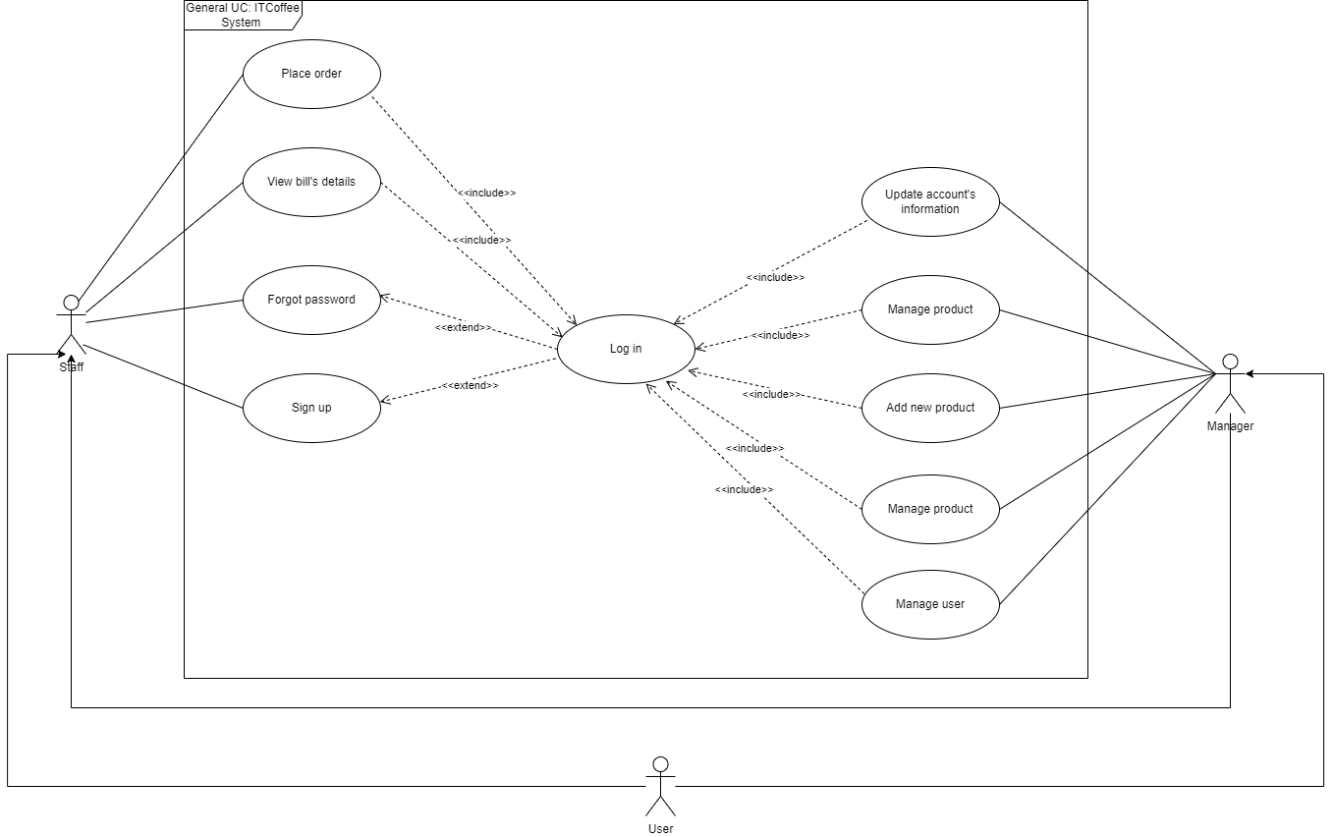

Figure 3: General use case diagram

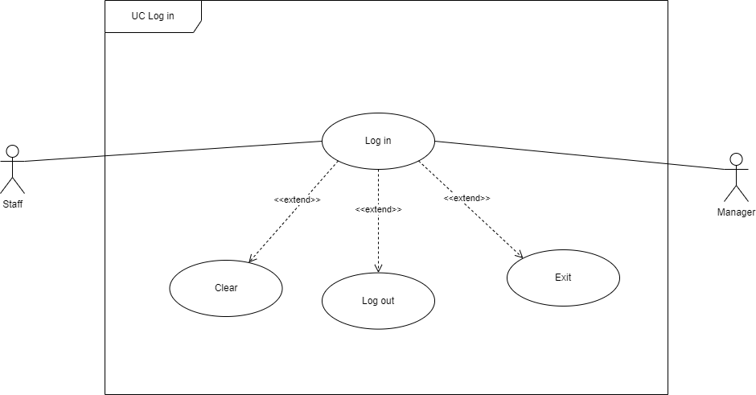Figure 4: Log in decomposition use case diagram

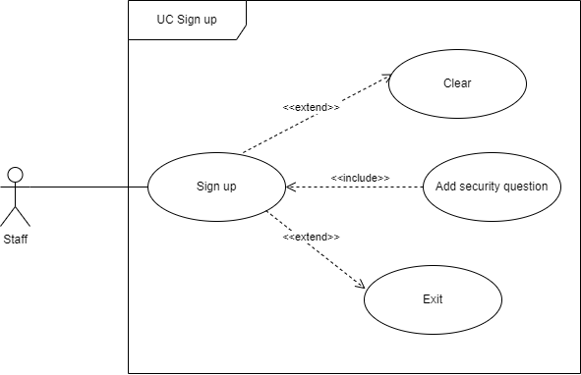Figure 5: Sign up decomposition use case diagram

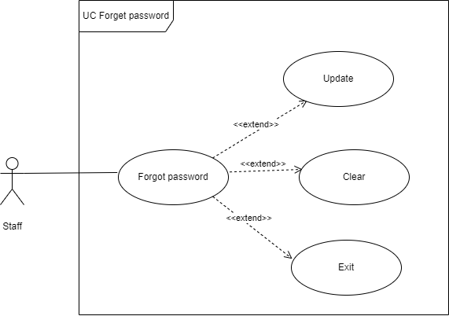Figure 6: Forgot password decomposition use case diagram

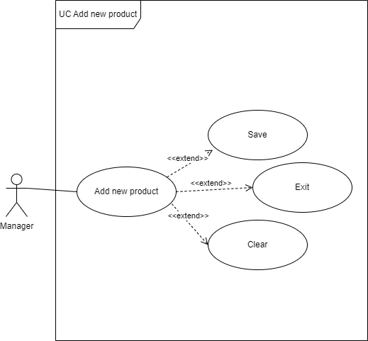

Figure 7: Add new product decomposition use case diagram

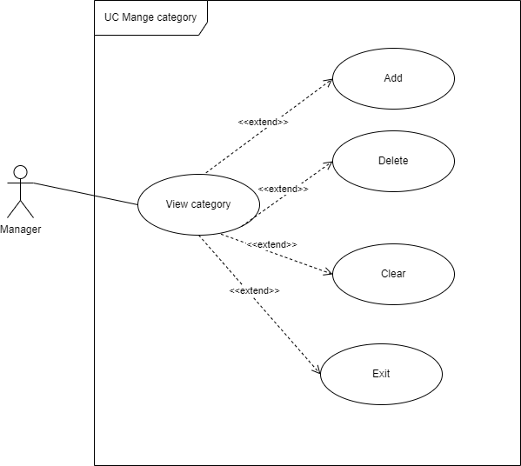

Figure 8: Manage category decomposition use case diagram

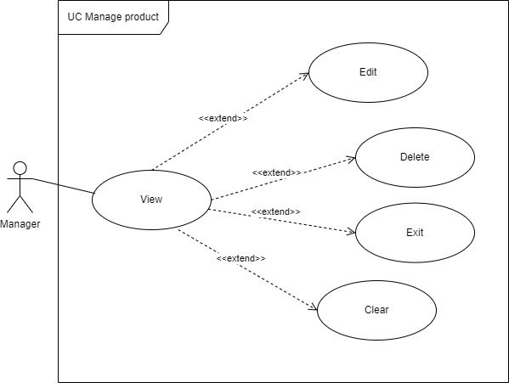

Figure 9: Manage product decomposition use case diagram

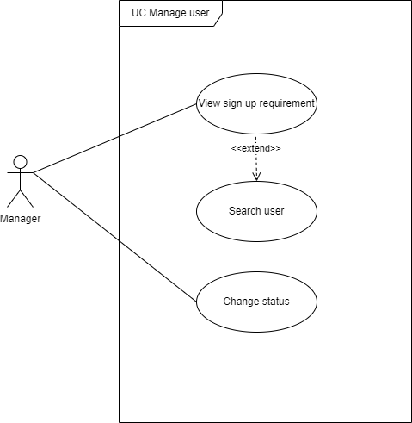

Figure 10: Manage user decomposition use case diagram

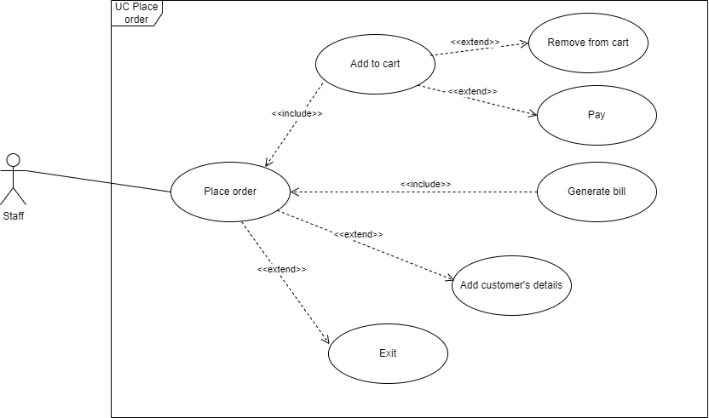

Figure 11: Place order decomposition use case diagram

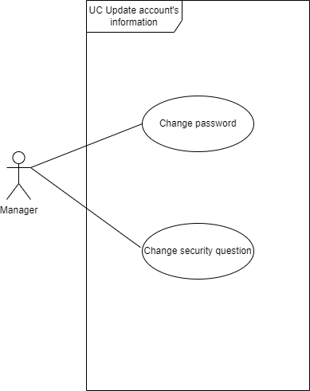

Figure 12: Update account’s information decomposition use case diagram

* 1. Textual description for each use case

|  |  |  |  |
| --- | --- | --- | --- |
| Use case: Log in | | ID: UC-01 | Priority: Must have |
| Actor: Staff, Manager | | | |
| Description: • To use the features of the system, users must log in | | | |
| Triggers: • The user want to access the system | | | |
| Preconditions: • An internet connection is required for the device, and an account has been created | | | |
| Normal Course: 1. System Access 2. Use a manager or staff account to log into the system | | Information of steps: 1. System Access 2.1 System for authenticating user accounts 2.2 Return login results | |
| Postconditions: • The user logged in successfully • The system successfully logged in | | | |
| Input Source | | Outputs Destination | |
| • System Access • Log in to the system | Staff, Manager | • Logged in successfully | Staff, Manager |

Table 4: Use case description 1

|  |  |  |  |
| --- | --- | --- | --- |
| Use case: Sign up | | ID: UC-02 | Priority: Must have |
| Actor: Staff | | | |
| Description: • A new account is created by the user on the system | | | |
| Triggers: • User creates new account | | | |
| Preconditions: • There must be an internet connection on the device | | | |
| Normal Course: 1. Visit the website 2. Choose the feature register an account 3. Verify account | | Information of steps: 1. Access logging system 2.1 Type in your username, password, security question, and email address 2.2 System for sending email verification messages 2.3 The system saves a new account 3.1 Recording successful registration | |
| Postconditions: • Create Account Success | | | |
| Input Source | | Outputs Destination | |
| • Create Account | Staff | • Create Account Success | Staff |

Table 5: Use case description 2

|  |  |  |  |
| --- | --- | --- | --- |
| Use case: Log out | | ID: UC-03 | Priority: Must have |
| Actor: Staff, Manager | | | |
| Description: • Users want to log out of the system when not in use | | | |
| Triggers: • User logs out of the system | | | |
| Preconditions: • Logged in successfully using an admin or staff account • There must be an internet connection on the device | | | |
| Normal Course: 1. Sign in using a manager or staff account. 2. Log out 3. Successfully sign out | | Information of steps: 1.1 Account authentication system 1.2 Return login results 2.1 User chooses to log out of the system 3.1 Return logout result | |
| Postconditions: • Log out of the system | | | |
| Input Source | | Outputs Destination | |
| • Log in to the system • Log out | Admin, Staff | • Logged in successfully • Sign out successful | Admin, Staff |

Table 6: Use case description 3

|  |  |  |  |
| --- | --- | --- | --- |
| Use case: Forgot password | | ID: UC-04 | Priority: Must have |
| Actor: Manager, Staff | | | |
| Description: • Users who forgot their password must reset their password to access their accounts. | | | |
| Triggers: • User wants to recover account with new password | | | |
| Preconditions: • Account was created • There must be an internet connection on the device | | | |
| Normal Course: 1. Access to the system 2. Reclaim your account | | Information of steps: 1.1 Access logging system 2.1 After entering their email, the user clicks "forgot password" 2.2 A security question and email account authentication system are displayed. 2.3 Type in your response 2.4 Returns validation results 2.5 Create a new password 2.6 System save new password 2.7 Database recording new data | |
| Postconditions: • Account recovery successful | | | |
| Input Source | | Outputs Destination | |
| • Get account back | Manager, Staff | • Account recovery successful | Manager, Staff |

Table 7: Use case description 4

|  |  |  |  |
| --- | --- | --- | --- |
| Use case: Update account information | | ID: UC-05 | Priority: Must have |
| Actor: Manager, Staff | | | |
| Description: • On the system, users update their personal data. | | | |
| Triggers: • User wants to update account information | | | |
| Preconditions: • Logged in successfully using an admin or staff account • There must be an internet connection on the device | | | |
| Normal Course: 1. Log in to the system with a manager or staff account 2. Update information 3. The update is completed | | Information of steps: 1.1 Account authentication system 1.2 Return login results 2.1 Proceed to the section on personal information 2.2 Update information 2.3 Save information to database 3.1 Database recording new data | |
| Postconditions: • Successfully updated personal information | | | |
| Input Source | | Outputs Destination | |
| • Log in to the system • Update personal information | Staff, Manager | • Logged in successfully • Update successful | Staff, Manager |

Table 8: Use case description 5

|  |  |  |  |
| --- | --- | --- | --- |
| Use case: Change security question | | ID: UC-06 | Priority: Must have |
| Actor: Staff, Manager | | | |
| Description: • Users can change their security questions to ensure their security | | | |
| Triggers: • User wants to change security question | | | |
| Preconditions: • logged in with staff or admin account • The device needs to have an internet connection | | | |
| Normal Course: 1. Log in to the system with customer or manager account 2. Change the question 3.Successful change | | Information of steps: 1.1 Account authentication system 1.2 Return login results 2.1 User enters answer to previous question 2.2 Authentication system 2.3 Enter new questions and answers 3.1 Change recording system | |
| Postconditions: • Change security question | | | |
| Input Source | | Outputs Destination | |
| • Log in to the system • Change the question | Staff, Manager | • Logged in successfully • Change the question successfully | Staff, Manager |

Table 9: Use case description 6

|  |  |  |  |
| --- | --- | --- | --- |
| Use case: Change password | | ID: UC-07 | Priority: Must have |
| Actor: Staff, Manager | | | |
| Description: • Users can change their password to ensure security | | | |
| Triggers: • User wants to change password | | | |
| Preconditions: • Successfully logged in with staff or admin account • The device needs to have an internet connection. | | | |
| Normal Course: 1. Log in to the system with a staff or manager account 2. Confirm | | Information of steps: 1.1 Account authentication system 1.2 Return login results 2.1 User enters old password 2.2 Authentication system 2.3 Enter a new password 3.1 Change recording system | |
| Postconditions: • Change password | | | |
| Input Source | | Outputs Destination | |
| • Log in to the system • Change the password | Staff, Manager | • Logged in successfully • Change password successfully | Staff, Manager |

Table 10: Use case description 7

|  |  |  |  |
| --- | --- | --- | --- |
| Use case: Place order | | ID: UC-08 | Priority: Must have |
| Actor: Staff, Manager | | | |
| Description: • Users can order according to customer requirements | | | |
| Triggers: • User wants to order | | | |
| Preconditions: • Successfully logged in with admin or staff account. • The device needs to have an internet connection. | | | |
| Normal Course: 1. Log in to the system with the manager or staff account 2. Order | | Information of steps: 1.1 Account authentication system 1.2 Return login results 2.1 Users place orders according to customer requirements 2.2 Order display system | |
| Postconditions: • Order | | | |
| Input Source | | Outputs Destination | |
| • Log in to the system • Order | Staff, Manager | • Logged in successfully • Order Success | Staff, Manager |

Table 11: Use case description 8

|  |  |  |  |
| --- | --- | --- | --- |
| Use case: Add to cart | | ID: UC-09 | Priority: Must have |
| Actor: Staff, Manager | | | |
| Description: • Users can add products to the cart before placing an order | | | |
| Triggers: • User adds product to cart | | | |
| Preconditions: • The device needs to have an internet connection. • Successfully logged in with admin or staff account. | | | |
| Normal Course: 1. Log in to the system with a manager or staff account 2. Add product to cart | | Information of steps: 1.1 Account authentication system 1.2 Return login results 2.1 Select the products you want to order 2.2 Add to cart 2.3 Display cart | |
| Postconditions: • Add product to cart | | | |
| Input Source | | Outputs Destination | |
| • Log in to the system • Add product to cart | Staff, Manager | • Logged in successfully • Product added to cart successfully | Staff, Manager |

Table 12: Use case description 9

|  |  |  |  |
| --- | --- | --- | --- |
| Use case: Pay | | ID: UC-10 | Priority: Must have |
| Actor: Staff, Manager | | | |
| Description: • User needs to process a payment for a customer after they have finished adding items to their cart. | | | |
| Triggers: • User view payment request list. | | | |
| Preconditions: • The device needs to have an internet connection. • Login successfully with admin account | | | |
| Normal Course: 1. Log in to the system with a manager or staff account 2. See list of requests | | Information of steps: 1.1 Choose payment requirement 1.2.1 If QR bank, then generate QR code 1.2.2 System updates payment status 1.3.1 If cash, then give it to staff 1.3.2 User confirms successful payment processing | |
| Postconditions: • User views payment request. • Payment processed according to chosen method(QR bank or cash) | | | |
| Input Source | | Outputs Destination | |
| • Log in to the system • See payment success | Staff, Manager | • Logged in successfully • See the list of completions | Staff, Manager |

Table 13: Use case description 10

|  |  |  |  |
| --- | --- | --- | --- |
| Use case: Generate bill | | ID: UC-11 | Priority: Must have |
| Actor: Staff, Manager | | | |
| Description: • Users create invoices once paid | | | |
| Triggers: • User creates invoice | | | |
| Preconditions: • The device needs to have an internet connection. • Successfully logged in with staff or admin account | | | |
| Normal Course: 1. Log in to the system with a manager or staff account 2. Create Invoice | | Information of steps: 1.1 Account authentication system 1.2 Return login results 2.1 Create invoices according to customer requirements when paid 2.2 Display of invoices | |
| Postconditions: • Create Invoice | | | |
| Input Source | | Outputs Destination | |
| • Log in to the system • Create Invoice | Staff, Manager | • Logged in successfully • Successful invoice generation | Staff, Manager |

Table 14: Use case description 11

|  |  |  |  |
| --- | --- | --- | --- |
| Use case: Add user's details | | ID: UC-12 | Priority: Must have |
| Actor: Staff, Manager | | | |
| Description: • The user adds customer information or requests to the order | | | |
| Triggers: • User adds information to the order | | | |
| Preconditions: • Successfully logged in with admin or staff account. • The device needs to have an internet connection. | | | |
| Normal Course: 1. Log in to the system with a manager or staff account 2. Add order information | | Information of steps: 1.1 Account authentication system 1.2 Return login results 2.1 Create an order 2.2 Add order information as required 2.3 Displaying order information | |
| Postconditions: • Add information to the order | | | |
| Input Source | | Outputs Destination | |
| • Log in to the system • Add information to the order | Staff, Manager | • Logged in successfully • Add details success | Staff, Manager |

Table 15: Use case description 12

|  |  |  |  |
| --- | --- | --- | --- |
| Use case: View bill details | | ID: UC-13 | Priority: Maybe not |
| Actor: Staff, Manager | | | |
| Description: • Users can view invoices and invoice details on the system | | | |
| Triggers: • User view invoice and invoice details | | | |
| Preconditions: • The device needs to have an internet connection. • Successfully logged in with admin or staff account | | | |
| Normal Course: 1. Log in to the system with a manager or staff account 2. View invoice and invoice details | | Information of steps: 1.1 Account authentication system 1.2 Return login results 2.1 User selects invoice to view 2.2 Show invoice details | |
| Postconditions: • View invoice and invoice details | | | |
| Input Source | | Outputs Destination | |
| • Log in to the system • View invoice and invoice details | Staff, Manager | • Logged in successfully • View invoice and complete invoice details | Staff, Manager |

Table 16: Use case description 13

|  |  |  |  |
| --- | --- | --- | --- |
| Use case: View bill in PDF | | ID: UC-14 | Priority: Maybe not |
| Actor: Staff, Manager | | | |
| Description: • User can view invoices in pdf format | | | |
| Triggers: • User view invoice in pdf format | | | |
| Preconditions: • The device needs to have an internet connection. • Successfully logged in with admin or staff account | | | |
| Normal Course: 1. Log in to the system with a manager or staff account 2. View invoices in pdf format | | Information of steps: 1.1 Account authentication system 1.2 Return login results 2.1 User selects invoice to view 2.2 Display invoices in pdf format | |
| Postconditions: • View invoices in pdf format | | | |
| Input Source | | Outputs Destination | |
| • Log in to the system • View invoices in pdf format | Staff, Manager | • Logged in successfully • View invoices in complete pdf format | Staff, Manager |

Table 17: Use case description 14

|  |  |  |  |
| --- | --- | --- | --- |
| Use case: Print bill | | ID: UC-15 | Priority: Must have |
| Actor: Staff, Manager | | | |
| Description: • User can print invoice | | | |
| Triggers: • User prints invoice | | | |
| Preconditions: • The device needs to have an internet connection. • There is a printing device. • Successfully logged in with admin or staff account | | | |
| Normal Course: 1. Log in to the system with a manager or staff account 2. Print invoice | | Information of steps: 1.1 Account authentication system 1.2 Return login results 2.1 User chooses to print invoice 2.2 Invoices are printed | |
| Postconditions: • Print invoice | | | |
| Input Source | | Outputs Destination | |
| • Log in to the system • Print invoice | Staff, Manager | • Logged in successfully • Print invoice successfully | Staff, Manager |

Table 18: Use case description 15

|  |  |  |  |
| --- | --- | --- | --- |
| Use case: View bill list | | ID: UC-16 | Priority: Must have |
| Actor: Staff, Manager | | | |
| Description: • User can view list of invoices | | | |
| Triggers: • The user views a list of invoices | | | |
| Preconditions: • The device needs to have an internet connection. • Successfully logged in with admin or staff account | | | |
| Normal Course: 1. Log in to the system with a manager or staff account 2. View list of bills | | Information of steps: 1.1 Account authentication system 1.2 Return login results 2.1 View a list of invoices | |
| Postconditions: • View list of bills | | | |
| Input Source | | Outputs Destination | |
| • Log in to the system • View list of bills | Staff, Manager | • Logged in successfully • View a list of completed invoices | Staff, Manager |

Table 19: Use case description 16

|  |  |  |  |
| --- | --- | --- | --- |
| Use case: Order by date | | ID: UC-17 | Priority: Maybe not |
| Actor: Staff, Manager | | | |
| Description: • User can sort invoices by date | | | |
| Triggers: • User sort invoices by date | | | |
| Preconditions: • The device needs to have an internet connection. • Successfully logged in with admin or staff account | | | |
| Normal Course: 1. Log in to the system with a manager or staff account 2. Sort invoices by date | | Information of steps: 1.1 Account authentication system 1.2 Return login results 2.1 Sort invoices by date 2.2 Display the list of sorted invoices | |
| Postconditions: • Sort invoices by date | | | |
| Input Source | | Outputs Destination | |
| • Log in to the system • Sort invoices by date | Staff, Manager | • Logged in successfully • Sort invoices by success date | Staff, Manager |

Table 20: Use case description 17

|  |  |  |  |
| --- | --- | --- | --- |
| Use case: Order by ID | | ID: UC-18 | Priority: Maybe not |
| Actor: Staff, Manager | | | |
| Description: • User can change the order of invoices by their ID | | | |
| Triggers: • User changes order of invoices | | | |
| Preconditions: • The device needs to have an internet connection. • Successfully logged in with admin or staff account | | | |
| Normal Course: 1. Log in to the system with a manager or staff account 2. Change the order of invoices | | Information of steps: 1.1 Account authentication system 1.2 Return login results 2.1 Change order 2.2 Display the list of invoices after changing the order | |
| Postconditions: • Change the order of invoices | | | |
| Input Source | | Outputs Destination | |
| • Log in to the system • Change the order of invoices | Staff, manager | • Logged in successfully • Change the order of successful invoices | Staff, manager |

Table 21: Use case description 18

|  |  |  |  |
| --- | --- | --- | --- |
| Use case: Manage category | | ID: UC-19 | Priority: Must have |
| Actor: Manager | | | |
| Description: • Users can manage product categories by operations | | | |
| Triggers: • Users manage product categories | | | |
| Preconditions: • The device needs to have an internet connection. • Successfully logged in with admin or staff account | | | |
| Normal Course: 1. Log in to the system with manager account 2. Manage product categories | | Information of steps: 1.1 Account authentication system 1.2 Return login results 2.1 Operations on product catalogs 2.2 Display of product categories | |
| Postconditions: • Manage product categories | | | |
| Input Source | | Outputs Destination | |
| • Log in to the system • Manage product categories | Manager | • Logged in successfully • Change the order of successful invoices | Manager |

Table 22: Use case description 19

|  |  |  |  |
| --- | --- | --- | --- |
| Use case: Add category | | ID: UC-20 | Priority: Must have |
| Actor: Manager | | | |
| Description: • User can add new product category. | | | |
| Triggers: •Users initiate the addition of a new product category. | | | |
| Preconditions: • The device must have an internet connection. • User successfully logs in with admin or staff account. | | | |
| Normal Course: 1. Log in to the system with a manager account 2. Add new product category | | Information of steps: 1.1 System authenticates user's account. 1.2.1 Return login results. 2.1 Perform operation to add new category. 2.2 System displays existing product category. | |
| Postconditions: • New product category is added successfully | | | |
| Input Source | | Outputs Destination | |
| • Log in to the system • Add new category success | Manager | • Logged in successfully • New product is added | Manager |

Table 23: Use case description 20

|  |  |  |  |
| --- | --- | --- | --- |
| Use case: View category | | ID: UC-21 | Priority: Must have |
| Actor: Manager | | | |
| Description: • Users can view product categories | | | |
| Triggers: • Users view product categories | | | |
| Preconditions: • The device needs to have an internet connection. • Successfully logged in with admin or staff account | | | |
| Normal Course: 1. Log in to the system with a manager account 2. View product categories | | Information of steps: 1.1 Account authentication system 1.2 Return login results 2.1 Show product categories | |
| Postconditions: • View product categories | | | |
| Input Source | | Outputs Destination | |
| • Log in to the system • View product categories | Manager | • Logged in successfully • View complete product catalogs | Manager |

Table 24: Use case description 21

|  |  |  |  |
| --- | --- | --- | --- |
| Use case: Delete category | | ID: UC-22 | Priority: Must have |
| Actor: Manager | | | |
| Description: • User can delete product categories | | | |
| Triggers: • User deletes product categories | | | |
| Preconditions: • The device needs to have an internet connection. • Successfully logged in with admin or staff account | | | |
| Normal Course: 1. Log in to the system with manager account 2. Delete product categories | | Information of steps: 1.1 Account authentication system 1.2 Return login results 2.1 Show product categories 2.2 Delete categories 2.3 Modification recording system | |
| Postconditions: • Delete product categories | | | |
| Input Source | | Outputs Destination | |
| • Log in to the system • Delete product categories | Manager | • Logged in successfully • Delete product categories successfully | Manager |

Table 25: Use case description 22

|  |  |  |  |
| --- | --- | --- | --- |
| Use case: Add new product | | ID: UC-23 | Priority: Must have |
| Actor: Manager | | | |
| Description: • Users can add new products to the system. | | | |
| Triggers: • Users add new products | | | |
| Preconditions: • The device needs to have an internet connection. • Successfully logged in with admin or staff account | | | |
| Normal Course: 1. Log in to the system with a manager account 2. Add new products | | Information of steps: 1.1 Account authentication system 1.2 Return login results 2.1 Show products 2.2 Add new products 2.3 Save into database 2.4 Modification recording system | |
| Postconditions: • Add new products | | | |
| Input Source | | Outputs Destination | |
| • Log in to the system • Add new products | Manager | • Logged in successfully • Add successful new products | Manager |

Table 26: Use case description 23

|  |  |  |  |
| --- | --- | --- | --- |
| Use case: Manage product | | ID: UC-24 | Priority: Must have |
| Actor: Manager | | | |
| Description: • Users can manage product by operations | | | |
| Triggers: • Users manage product categories | | | |
| Preconditions: • The device needs to have an internet connection. • Successfully logged in with admin or staff account | | | |
| Normal Course: 1. Log in to the system with a manager account 2. Manage product categories | | Information of steps: 1.1 Account authentication system 1.2 Return login results 2.1 Operations on product catalogs 2.2 Display of product | |
| Postconditions: • Manage product categories | | | |
| Input Source | | Outputs Destination | |
| • Log in to the system • Manage product categories | Manager | • Logged in successfully • View product success | Manager |

Table 27: Use case description 24

|  |  |  |  |
| --- | --- | --- | --- |
| Use case: View product | | ID: UC-25 | Priority: Must have |
| Actor: Manager | | | |
| Description: • Users can view product information on the system | | | |
| Triggers: • Users view the information of the product | | | |
| Preconditions: • The device needs to have an internet connection. • Successfully logged in with admin or staff account | | | |
| Normal Course: 1. Log in to the system with a manager account 2. View product information | | Information of steps: 1.1 Account authentication system 1.2 Return login results 2.1 Show products | |
| Postconditions: • View product information | | | |
| Input Source | | Outputs Destination | |
| • Log in to the system • View product information | Manager | • Logged in successfully • View the information of the finished product | Manager |

Table 28: Use case description 25

|  |  |  |  |
| --- | --- | --- | --- |
| Use case: Edit product | | ID: UC-26 | Priority: Must have |
| Actor: Manager | | | |
| Description: • Users can edit product information on the system | | | |
| Triggers: • User edits product information | | | |
| Preconditions: • The device needs to have an internet connection. • Successfully logged in with admin or staff account | | | |
| Normal Course: 1. Log in to the system with a manager account 2. Edit product information | | Information of steps: 1.1 Account authentication system 1.2 Return login results 2.1 Show products 2.2 Editing product information 2.3 Modification recording system | |
| Postconditions: • Edit product information | | | |
| Input Source | | Outputs Destination | |
| • Log in to the system • Edit product information | Manager | • Logged in successfully • Edit product information | Manager |

Table 29: Use case description 26

|  |  |  |  |
| --- | --- | --- | --- |
| Use case: Delete product | | ID: UC-27 | Priority: Must have |
| Actor: Manager | | | |
| Description: • Users can delete product information on the system | | | |
| Triggers: • The user deletes the information of the product | | | |
| Preconditions: • The device needs to have an internet connection. • Successfully logged in with admin or staff account | | | |
| Normal Course: 1. Log in to the system with a manager account 2. Delete product information | | Information of steps: 1.1 Account authentication system 1.2 Return login results 2.1 Show products 2.2 Deleting products 2.3 Modification recording system | |
| Postconditions: • Delete product information | | | |
| Input Source | | Outputs Destination | |
| • Log in to the system • Delete product information | Manager | • Logged in successfully • Delete the information of the product successfully | Manager |

Table 30: Use case description 27

|  |  |  |  |
| --- | --- | --- | --- |
| Use case: Manage user | | ID: UC-28 | Priority: Must have |
| Actor: Manager | | | |
| Description: • Users can authenticate users and assign permissions when they create new accounts or change passwords | | | |
| Triggers: • User confirms account | | | |
| Preconditions: • The device needs to have an internet connection. • Login successfully with admin account | | | |
| Normal Course: 1. Log in to the system with a manager account 2. Verify account | | Information of steps: 1.1 Account authentication system 1.2 Return login results 2.1 Account confirmation | |
| Postconditions: • Verify account | | | |
| Input Source | | Outputs Destination | |
| • Log in to the system • Verify account | Manager | • Logged in successfully • Account confirmation successful | Manager |

Table 31: Use case description 28

|  |  |  |  |
| --- | --- | --- | --- |
| Use case: Search sign up request | | ID: UC-29 | Priority: Must have |
| Actor: Manager | | | |
| Description: • Users can search for new account creation requirements | | | |
| Triggers: • Users looking for requests to create a new account | | | |
| Preconditions: • The device needs to have an internet connection. • Login successfully with admin account | | | |
| Normal Course: 1. Log in to the system with a manager account 2. Look for requests to create a new account | | Information of steps: 1.1 Account authentication system 1.2 Return login results 2.1 Enter request 2.2 Return search results | |
| Postconditions: • Verify account | | | |
| Input Source | | Outputs Destination | |
| • Log in to the system • Look for requests to create a new account | Manager | • Logged in successfully • Searching for successful new account creation requests | Manager |

Table 32: Use case description 29

|  |  |  |  |
| --- | --- | --- | --- |
| Use case: View sign up require | | ID: UC-30 | Priority: Must have |
| Actor: Manager | | | |
| Description: • User can see the list of requests sent to the system | | | |
| Triggers: • User view list of requests | | | |
| Preconditions: • The device needs to have an internet connection. • Login successfully with admin account | | | |
| Normal Course: 1. Log in to the system with a manager account 2. See list of requests | | Information of steps: 1.1 Account authentication system 1.2 Return login results 2.1 Display the list of requirements available on the system | |
| Postconditions: • See list of requests | | | |
| Input Source | | Outputs Destination | |
| • Log in to the system • See list of requests | Manager | • Logged in successfully • See the list of completions | Manager |

Table 33: Use case description 30

|  |  |  |  |
| --- | --- | --- | --- |
| Use case: Change account's status | | ID: UC-31 | Priority: Must have |
| Actor: Manager | | | |
| Description: • User can change user status | | | |
| Triggers: • User interact the list | | | |
| Preconditions: • The device needs to have an internet connection. • Login successfully with admin account | | | |
| Normal Course: 1. Log in to the system with a manager account 2. See list of requests | | Information of steps: 1.1 Account authentication system 1.2 Return login results 2.1 Select account 2.2 Change status | |
| Postconditions: • See list of requests | | | |
| Input Source | | Outputs Destination | |
| • Log in to the system • See list account | Manager | • Logged in successfully • Change status success | Manager |

Table 34: Use case description 31

|  |  |  |  |
| --- | --- | --- | --- |
| Use case: Clear | | ID: UC-32 | Priority: Must have |
| Actor: Staff, Manager | | | |
| Description: • Users can delete the filled information in form or interface. | | | |
| Triggers: • User deletes all filled information | | | |
| Preconditions: • Successfully logged in with manager or staff account. • The device needs to have an internet connection. | | | |
| Normal Course: 1. Log in to the system with a manager or staff account 2. Delete information in form | | Information of steps: 1.1 Account authentication system 1.2 Return login results 2.1 User deletes information form 2.2 The system displays the original form | |
| Postconditions: • User can re-fill information. | | | |
| Input Source | | Outputs Destination | |
| • Log in to the system • Delete filled information | Manager, Staff | • Logged in successfully • Delete form successfully | Manager, Staff |

Table 35: Use case description 32

|  |  |  |  |
| --- | --- | --- | --- |
| Use case: Exit | | ID: UC-33 | Priority: Must have |
| Actor: Staff, Manager | | | |
| Description: • Users can exit form or interface. | | | |
| Triggers: • User exit form or interface. | | | |
| Preconditions: • Successfully logged in with manager or staff account. • The device needs to have an internet connection. | | | |
| Normal Course: 1. Log in to the system with a manager or staff account 2. Exit form or interface | | Information of steps: 1.1 Account authentication system 1.2 Return login results 2.1 User exit the current form or interface. 2.2 The system displays the lobby interface. | |
| Postconditions: • User can re-fill information. | | | |
| Input Source | | Outputs Destination | |
| • Log in to the system • Exit form or interface | Manager, Staff | • Logged in successfully • Exit successfully | Manager, Staff |

Table 36: Use case description 33

|  |  |  |  |
| --- | --- | --- | --- |
| Use case: Remove from cart | | ID: UC-34 | Priority: Must have |
| Actor: Staff, Manager | | | |
| Description: • Users can remove products from the cart. | | | |
| Triggers: • User remove product from cart | | | |
| Preconditions: • The device needs to have an internet connection. • Successfully logged in with admin or staff account. | | | |
| Normal Course: 1. Log in to the system with a manager or staff account 2. Remove product from cart | | Information of steps: 1.1 Account authentication system 1.2 Return login results 2.1 Select the products you want to order 2.2 Remove product from cart 2.3 Display cart | |
| Postconditions: • Add product to cart | | | |
| Input Source | | Outputs Destination | |
| • Log in to the system • Remove product from cart | Staff, Manager | • Logged in successfully • Product remove from cart successfully | Staff, Manager |

Table 37: Use case description 34

* 1. Activity diagrams model

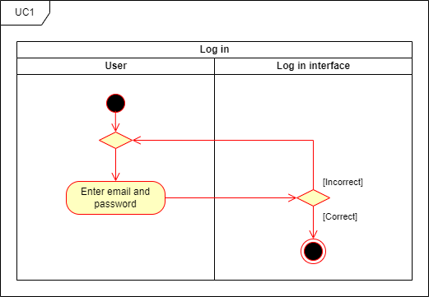

Figure 13: Log in activity diagram

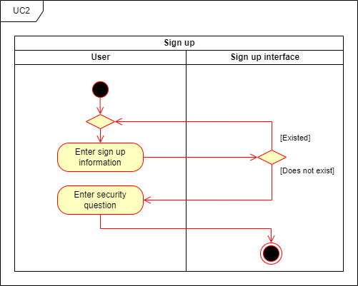

Figure 14: Sign up activity diagram

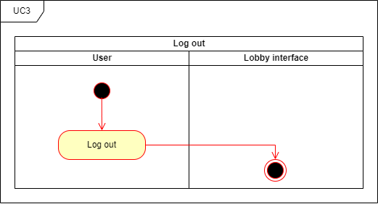

Figure 15: Log out activity diagram

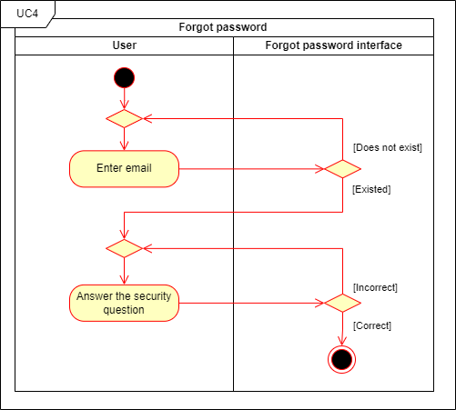

Figure 16: Forgot password activity diagram

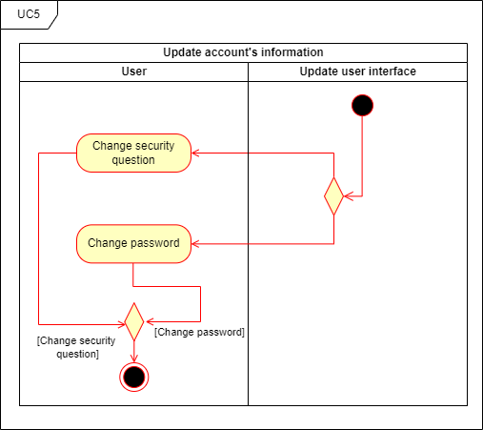

Figure 17: Update account’s information activity diagram

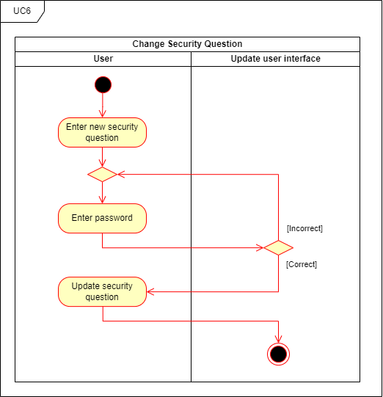

Figure 18: Change security question activity diagram

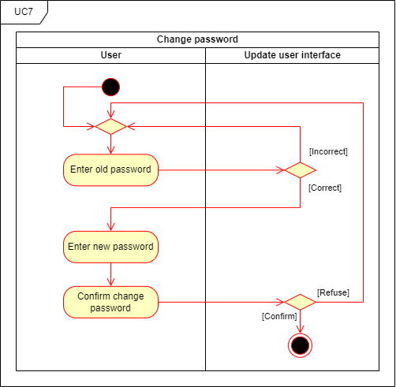

Figure 19: Change password activity diagram

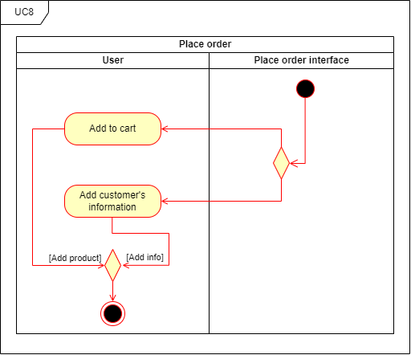

Figure 20: Place order activity diagram

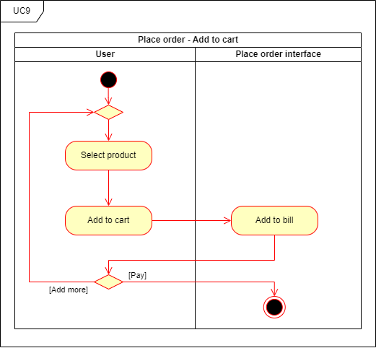

Figure 21: Place order - Add to cart activity diagram

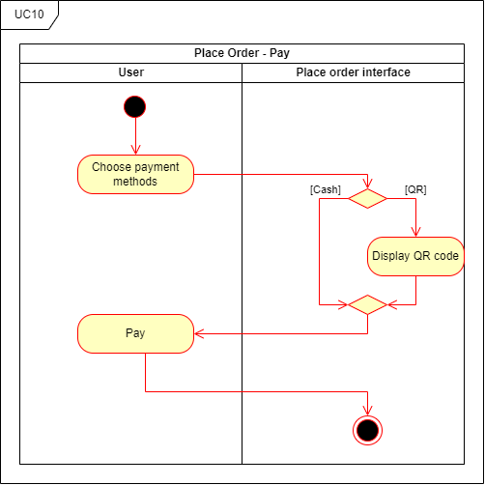

Figure 22: Place order – Pay activity diagram

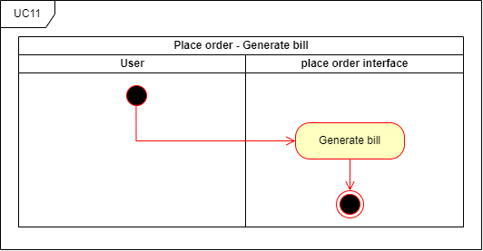

Figure 23: Place order – Generate bill activity diagram

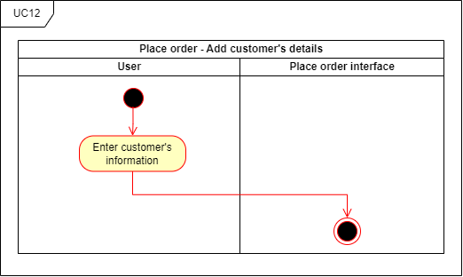

Figure 24: Place order – Add customer’s details activity diagram

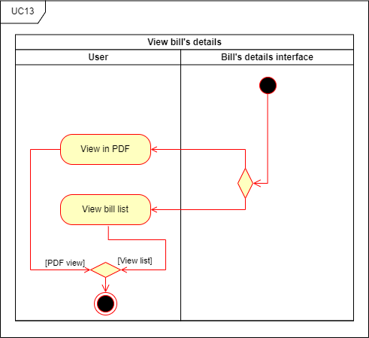

Figure 25: View bill’s details activity diagram

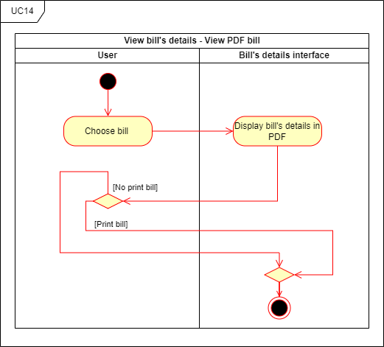

Figure 26: View bill’s details – View PDF bill activity diagram

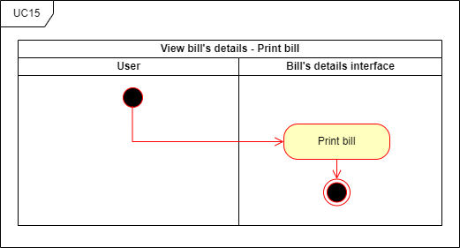  
Figure 27: View bill’s details – Print bill activity diagram

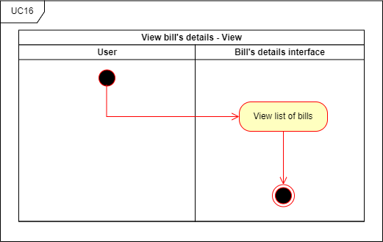

Figure 28: View bill’s details – View activity diagram

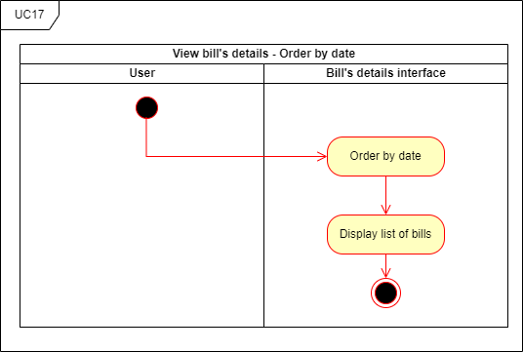

Figure 29: View bill’s details – Order by date activity diagram

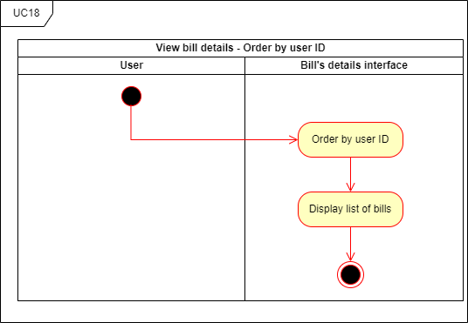

Figure 30: View bill’s details – Order by user ID activity diagram

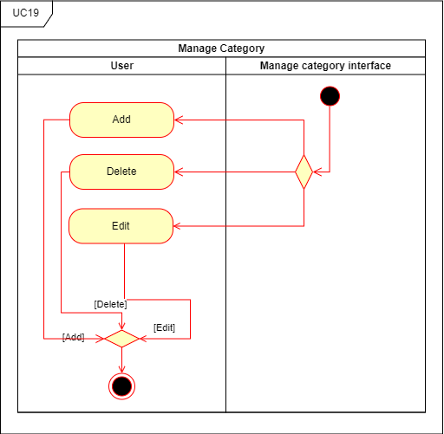

Figure 31: Manage category activity diagram

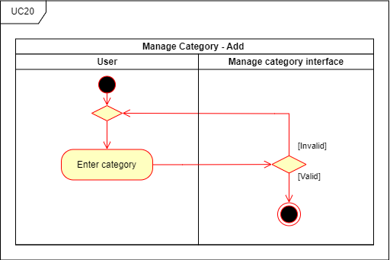

Figure 32: Manage category – Add activity diagram

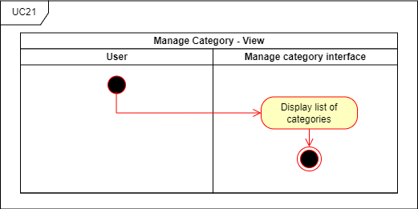

Figure 33: Manage category – View activity diagram

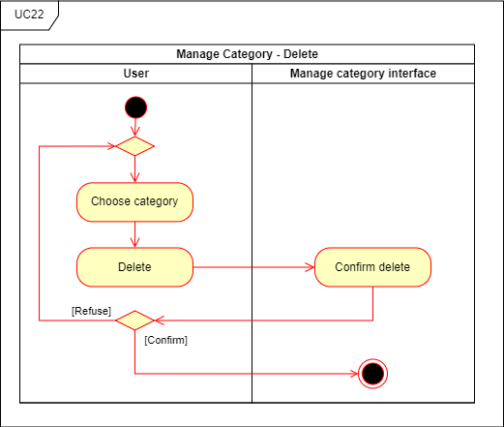

Figure 34: Manage category – Delete activity diagram

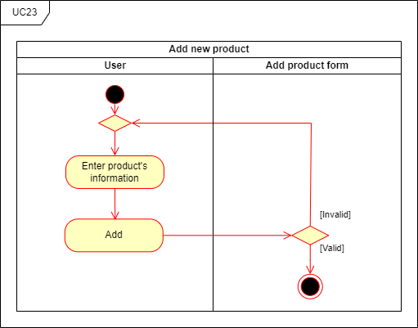

Figure 35: Add new product activity diagram

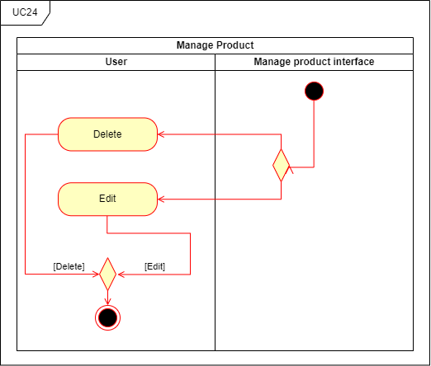

Figure 36: Manage product activity diagram

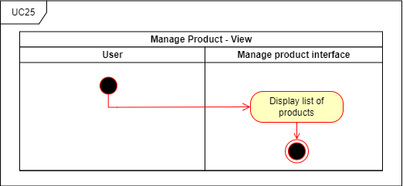

Figure 37: Manage product – View activity diagram

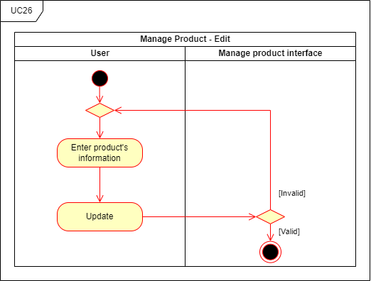

Figure 38: Manage product – Edit activity diagram

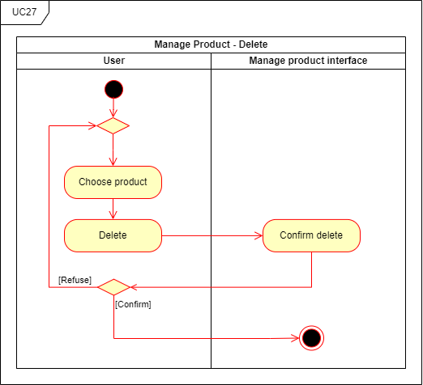

Figure 39: Manage product – Delete activity diagram

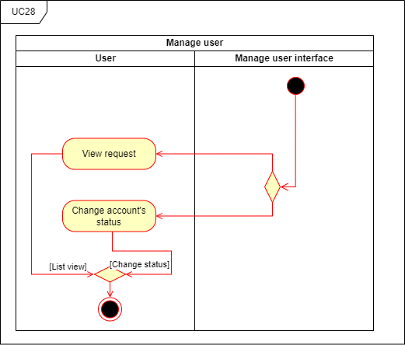

Figure 40: Manage user activity diagram

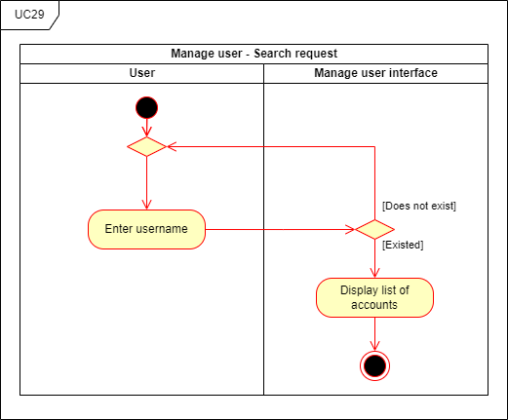

Figure 41: Manage user – Search request activity diagram

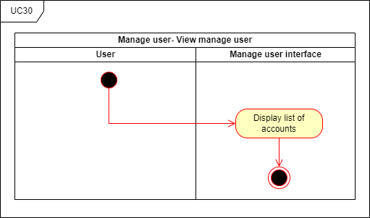

Figure 42: Manage user – View manage user activity diagram

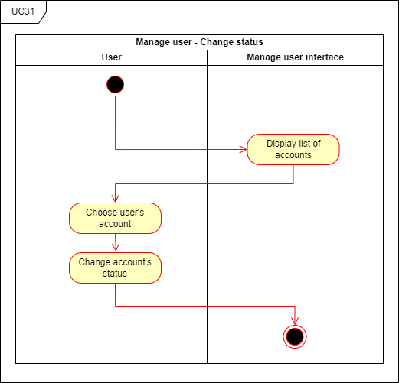

Figure 43: Manage user – Change status activity diagram

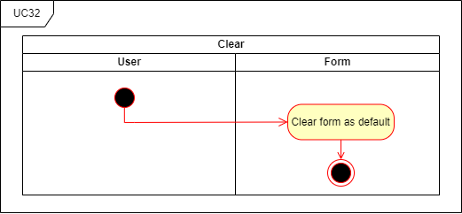

Figure 44: Clear activity diagram

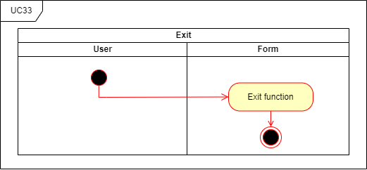

Figure 45: Exit activity diagram

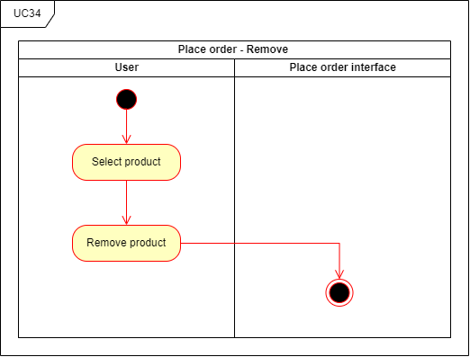

Figure 46: Place order – Remove activity diagram

* 1. **Sequence diagrams model**

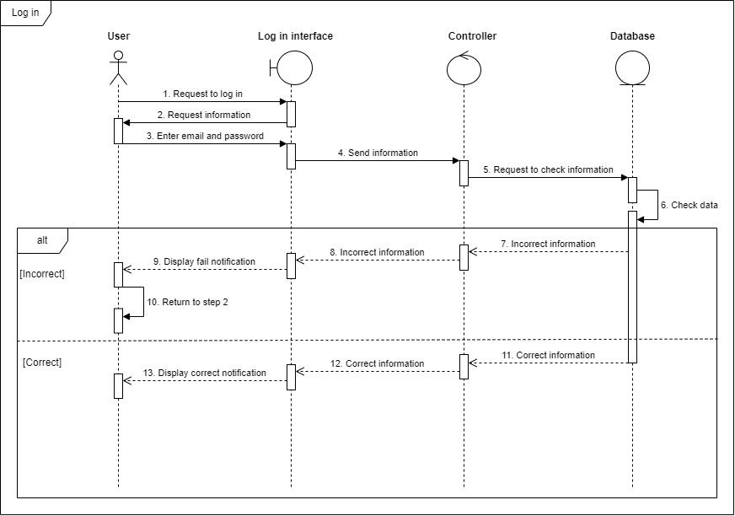

Figure 47: Log in sequence diagram

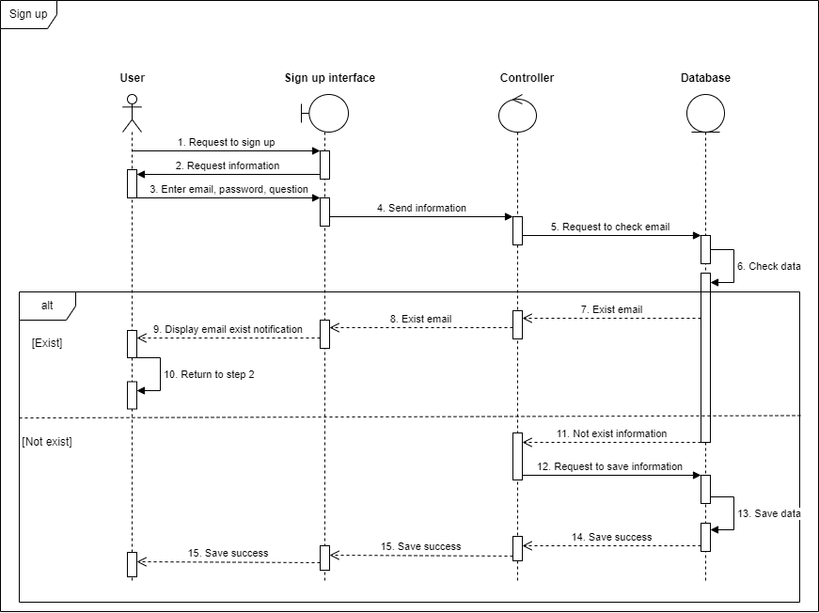

Figure 48: Sign up sequence diagram

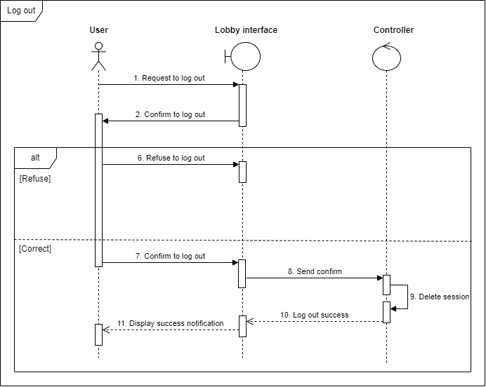

Figure 49: Log out sequence diagram

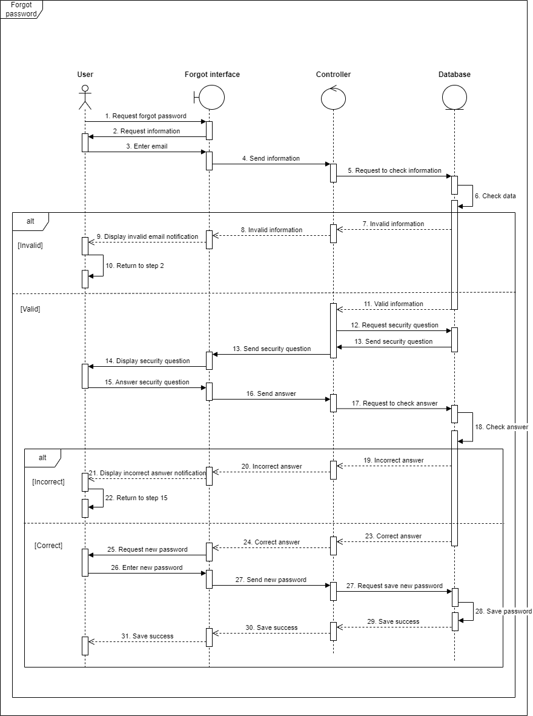

Figure 50: Forgot password sequence diagram

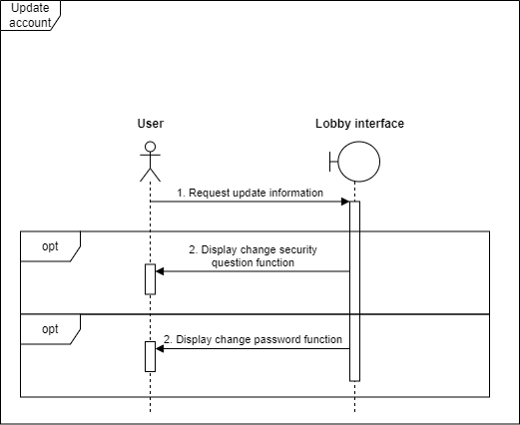

Figure 51: Update account sequence diagram

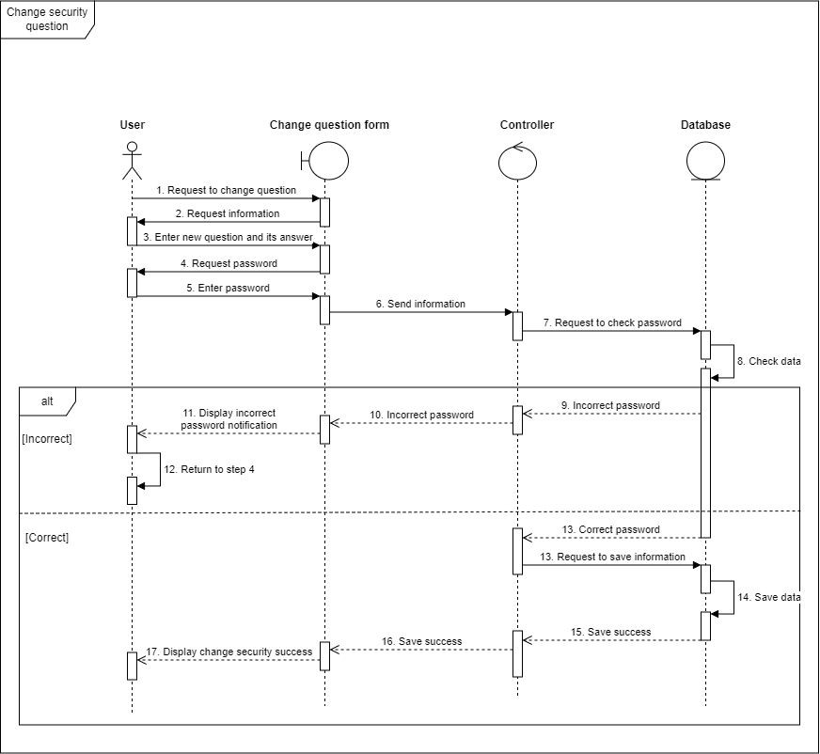

Figure 52: Change security question sequence diagram

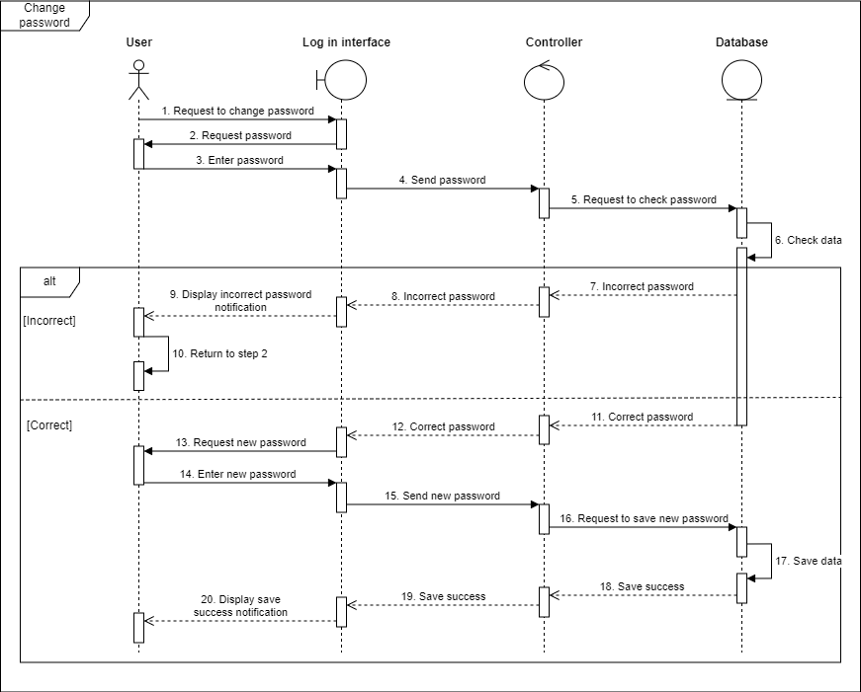

Figure 53: Change password sequence diagram

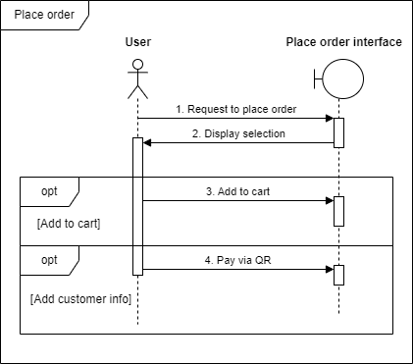

Figure 54: Place order sequence diagram

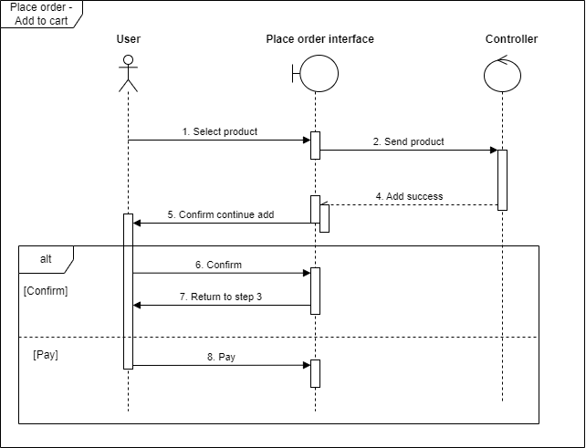

Figure 55: Place order – Add to cart sequence diagram

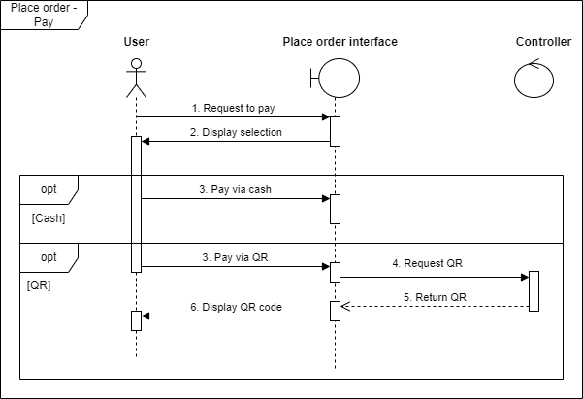

Figure 56: Place order – Pay sequence diagram

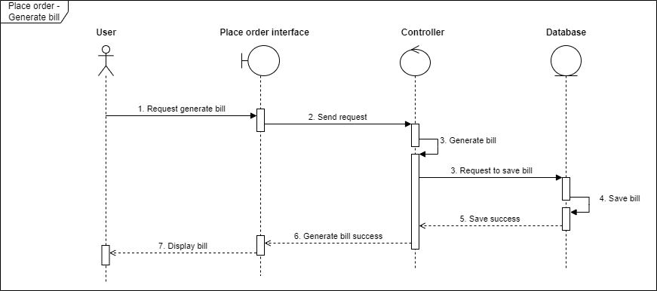

Figure 57: Place order – Generate bill sequence diagram

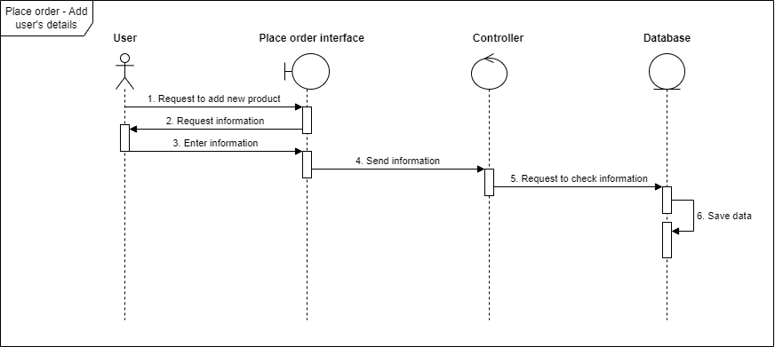

Figure 58: Place order – Add user’s details sequence diagram

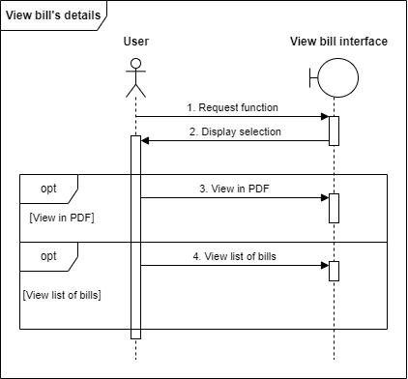

Figure 59: View bill’s details sequence diagram

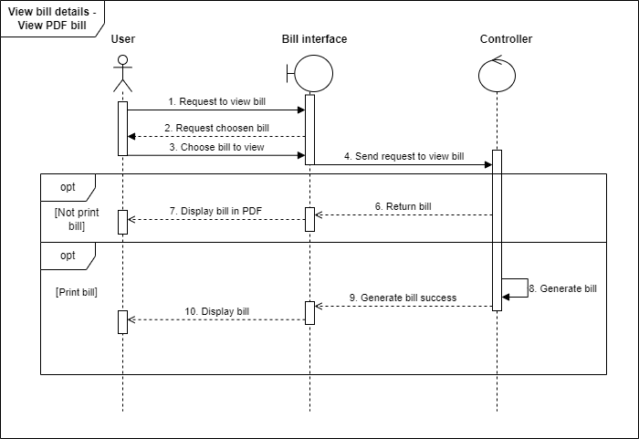

Figure 60: View bill’s details – View PDF bill sequence diagram

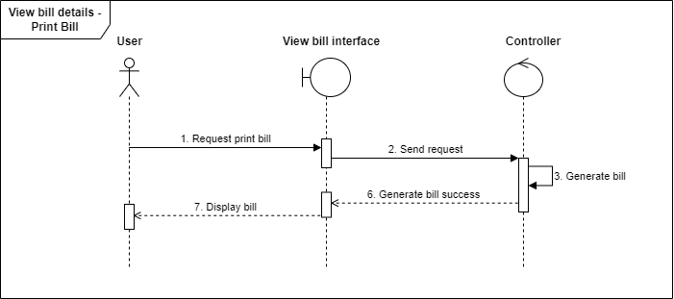

Figure 61: View bill’s details – Print bill sequence diagram

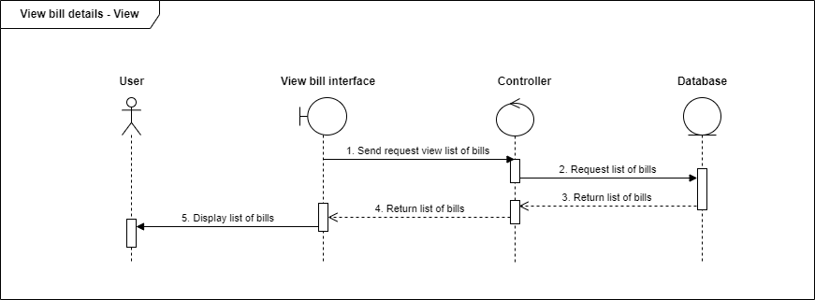

Figure 62: View bill ‘details – View sequence diagram

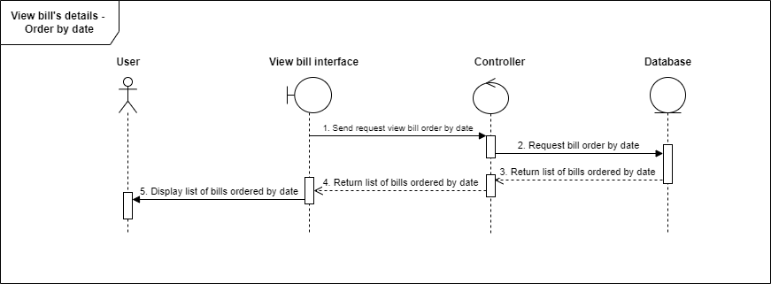

Figure 63: View bill’s details – Order by date sequence diagram

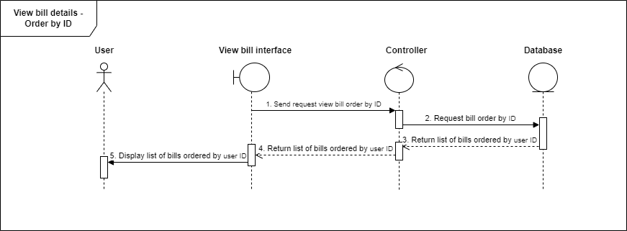

Figure 64: View bill’s details – Order by user ID sequence diagram

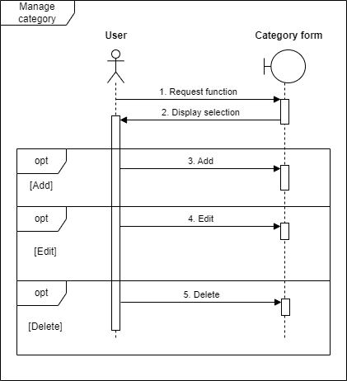

Figure 65: Manage category sequence diagram

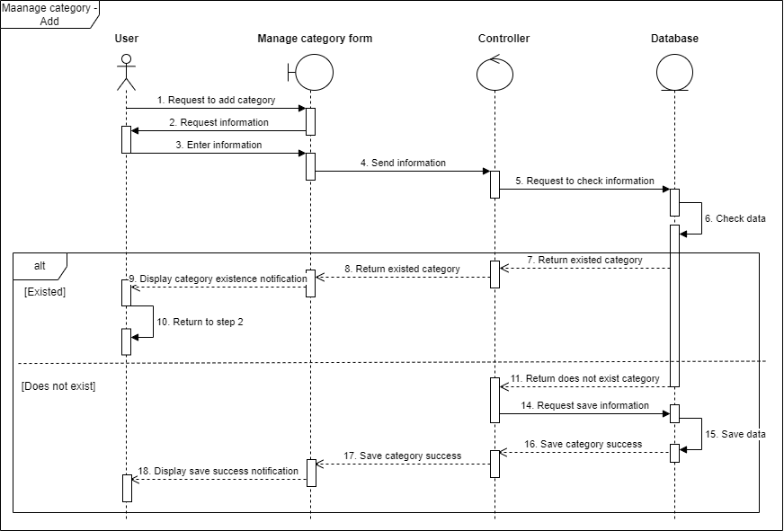

Figure 66: Manage category – Add sequence diagram

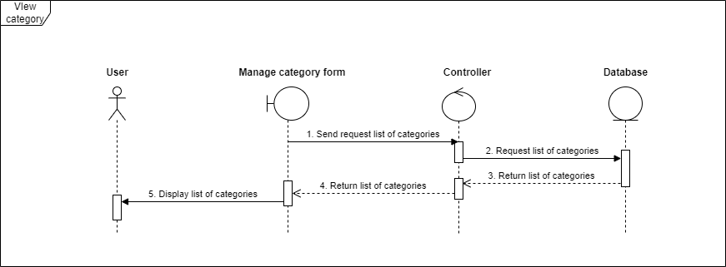

Figure 67: View category sequence diagram

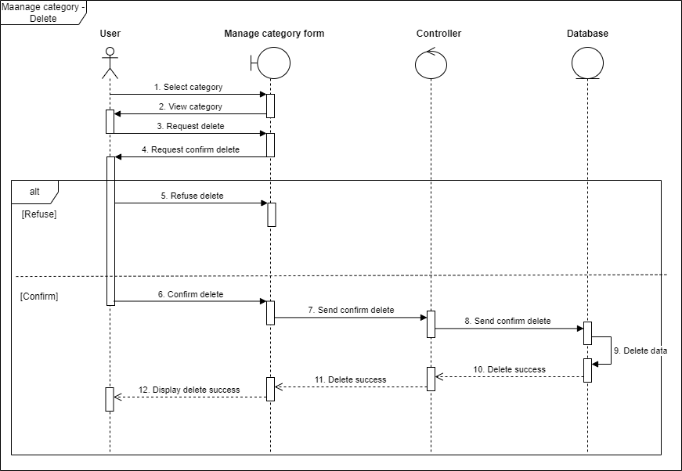

Figure 68: Manage category – Delete sequence diagram

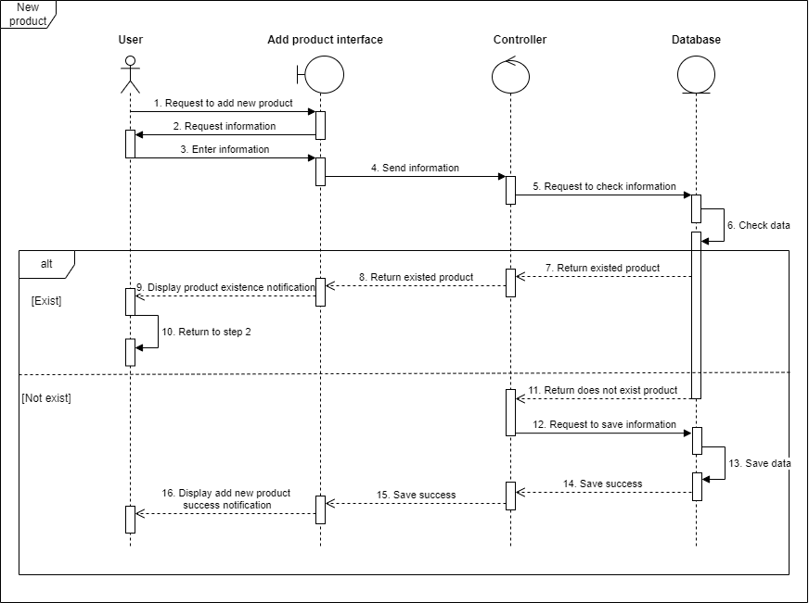

Figure 69: Add new product sequence diagram

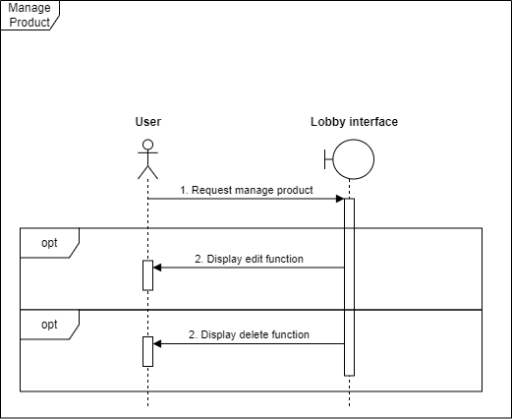

Figure 70: Manage product sequence diagram

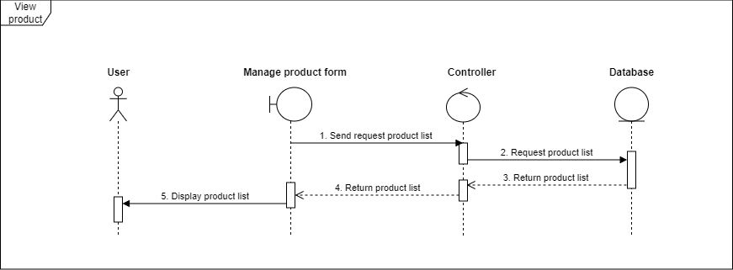

Figure 71: View product sequence diagram

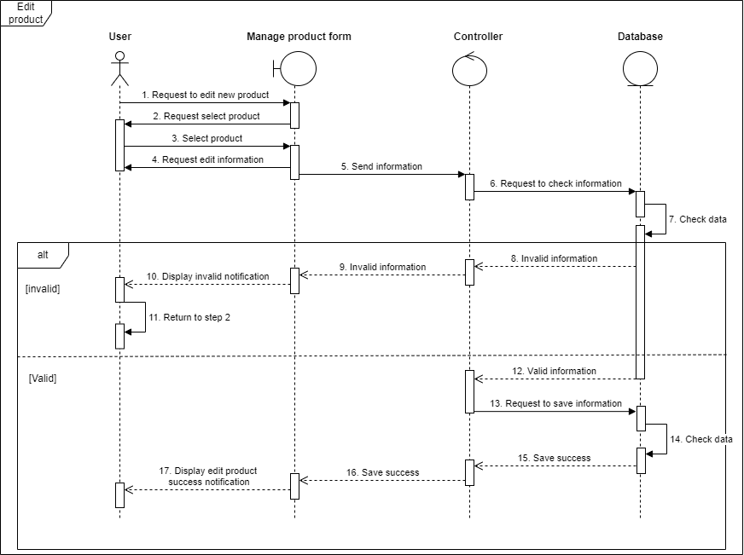

Figure 72: Edit product sequence diagram

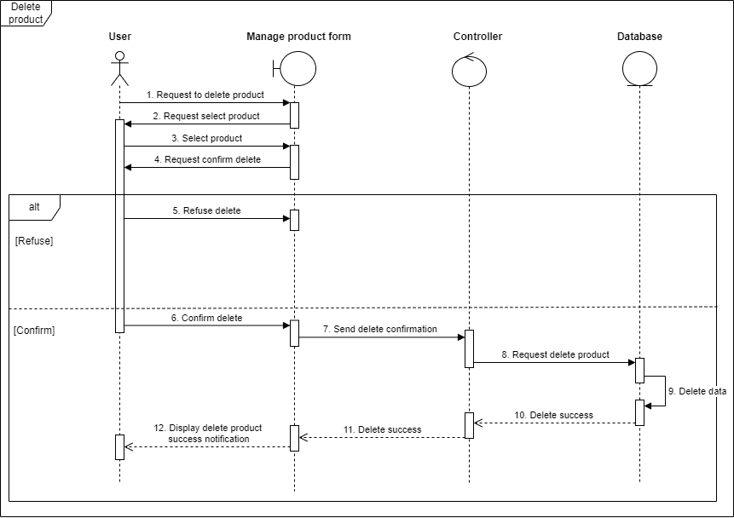

Figure 73: Delete product sequence diagram

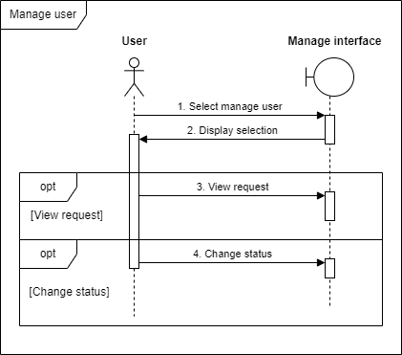

Figure 74: Manage user sequence diagram

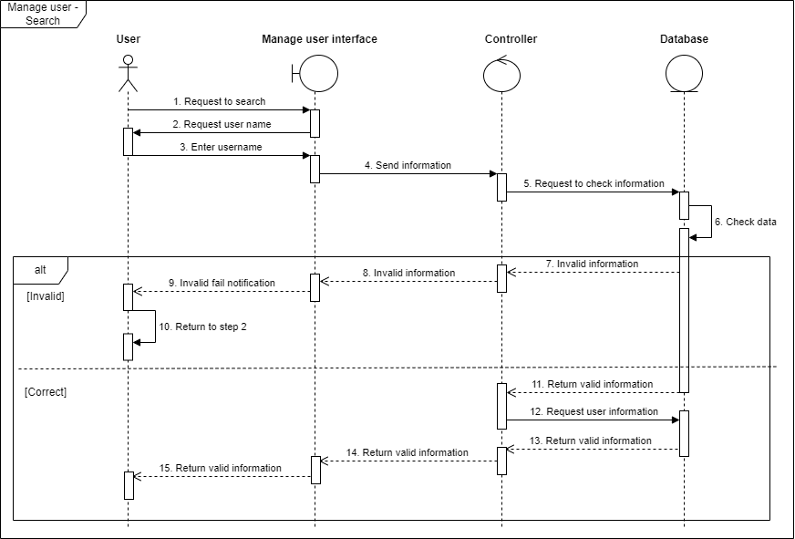

Figure 75: Manage user – Search sequence diagram

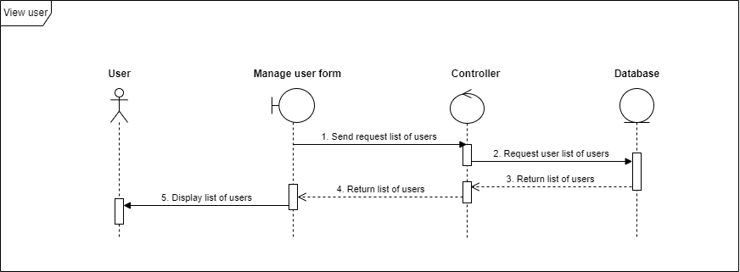

Figure 76: View user sequence diagram

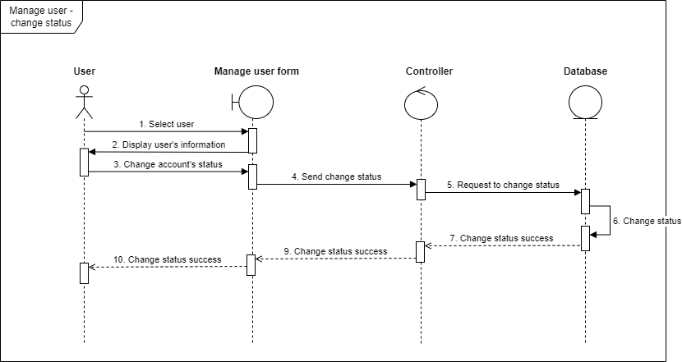

Figure 77: Manage user – Change status sequence diagram

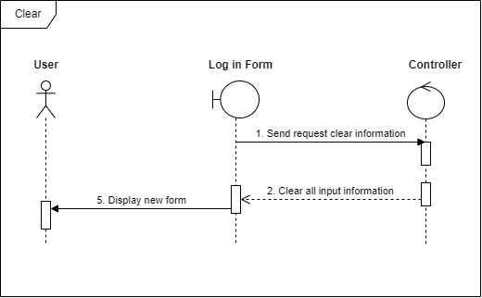

Figure 78: Clear sequence diagram

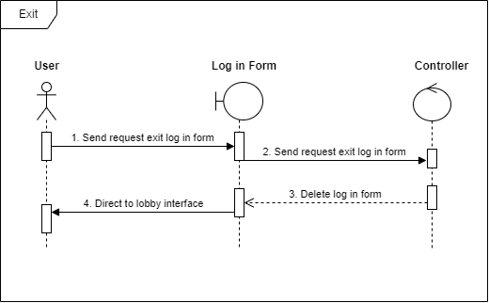

Figure 79: Exit sequence diagram

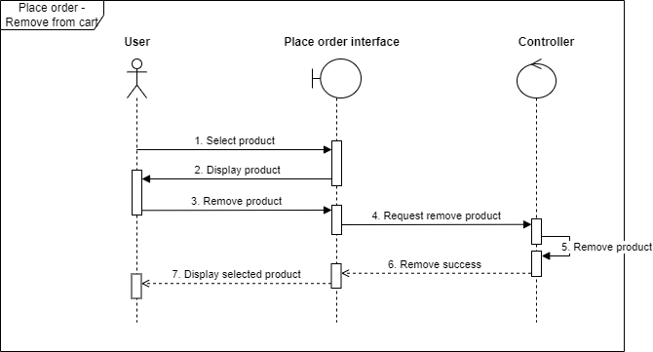

Figure 80: Place order – Remove from cart sequence diagram

1. Functional requirements

|  |  |  |
| --- | --- | --- |
| **No** | **Requirement name** | **Meaning** |
| 1 | Forgot password function. | Used in case the actor forgot the password. |
| 2 | Require security question when register or log in. | Adding a separate question that only the account knows for more effective security and prevent others from logging in even if they know the password. |
| 3 | Verify account after register by system manager. | Manager approves staffs use rights and can use all functions. |
| 4 | Add clear button | Adding a clear button in any function have a textbox to easily clear the text. |
| 5 | Require adding customer information when generating bill. | Adding customer information when generating bill. |
| 6 | Generate bill in to .pdf format. | After generating bill, it will generate in the .pdf format for printing. |
| 7 | Have a search bar in any function show a list. | Having a search bar in case there is large list and hard to find the row. |
| 8 | Manager can use any function that staffs have. | Manager approves staffs use rights and can use all functions. |
| 9 | Have some filters. | Require filters like date or ID when finding in bill list… |

Table 38: Functional requirements

1. Non-functional requirements

|  |  |  |
| --- | --- | --- |
| **No** | **Requirement name** | **Meaning** |
| 1 | Friendly interface. | Easy to use interface for non-technical staffs. |
| 2 | Easy to maintain. | It’s easy to fix and find out if there’s an error. |

Table 39: Non-functional requirements

CHAPTER 4: TECHNOLOGY IS USED

4.1 Programming language: Java (Jframe GUI)

The JFrame is a class of java.swing package which is inherited and extended from the Java AWT package. It is used for creating lightweight window applications. It includes various components such as labels, panels, buttons, etc. for creating a beautiful Graphical User Interface (GUI).

Above all, every Java Swing application starts by implementing a JFrame. As a result, it is basically a top-level container to create window-based applications. The class JFrame is an extended version of java.awt.Frame that adds support for the JFC/Swing component architecture.

4.2 Architecture: JFC/Swing component architecture

Java Swing is a lightweight Java graphical user interface (GUI) widget toolkit that includes a rich set of widgets. It is part of the Java Foundation Classes (JFC) and includes several packages for developing rich desktop applications in Java. Swing includes built-in controls such as trees, image buttons, tabbed panes, sliders, toolbars, color choosers, tables, and text areas to display HTTP or rich text format (RTF). Swing components are written entirely in Java and thus are platform independent.

4.3 Software: Apache Netbeans compiler

|  |  |  |  |  |
| --- | --- | --- | --- | --- |
| Platform | Processor (MHz) | Memory (MB) | Disk (MB) | Screen resolution |
| Linux on Intel | 233 | 128 | 75 | 800 X 600 |
| Mac OS X | 400 | 256 | 75 | Any modern color display |
| Solaris on Intel | 330 | 256 | 75 | 1024 X 768 |
| Solaris on Sparc | Ultra Sparc II 300 | 512 | 75 | 1024 X 768 |
| Windows on Intel | 330 | 192 | 75 | 800 X 600 |

Table 40: Apache Netbeans OS requirement

4.4 Source code management: Git

A crucial component of software engineering, source code management—alsoknown as version control—manages changes to documents, large websites, computer programs, and other data sets. Git is a fast, flexible, distributed revision control system that is unique in that it has a wide range of commands that provide both advanced features and in-depth access to underlying mechanisms. As such, Git supersedes alternatives such as Apache Subversion and Mercurial in this project.

Our project: [ITCOFFEE-SYSTEM](https://github.com/this-is-duykhanh/ITCOFFEE-SYSTEM)

4.5 Architectural model: UML (Unified Modeling Language)

UML can be described as a general-purpose visual modeling language to visualize, specify, construct, and document a software system. Although UML is generally used to model software system, it is not limited within this boundary. It is also used to model non software systems such as process flows in a manufacturing unit.

The elements are like components which can be associated in different ways to make a complete UML picture, which is known as a diagram. So, it is very important to understand the different diagrams to implement the knowledge in real-life systems. We have two broad categories of diagrams, and they are further divided into sub-categories i.e. Structural Diagrams and Behavioral Diagrams.

|  |  |  |
| --- | --- | --- |
| Sr.No. | Diagram & Description | Used in this project |
| 1 | Class: Represents the object orientation of a system. Shows how classes are statically related. | X |
| 2 | Object: Represents a set of objects and their relationships at runtime and represent the static view of the system. |  |
| 3 | Component: Describes all the components, their interrelationship, interactions, and interface of the system. |  |
| 4 | Composite structure: Describes inner structure of component including all classes, interfaces of the component, etc. |  |
| 5 | Package: Describes the package structure and organization. Covers classes in the package and packages within another package. |  |
| 6 | Deployment: Deployment diagrams are a set of nodes and their relationships. These nodes are physical entities where the components are deployed. |  |

Table 41: Structure diagram in use

|  |  |  |
| --- | --- | --- |
| Sr.No. | Diagram & Description | Used in this project |
| 1 | Use case: Describes the relationships among the functionalities and their internal/external controllers. These controllers are known as actors. | X |
| 2 | Activity: Describes the flow of control in a system. It consists of activities and links. The flow can be sequential, concurrent, or branched. | X |
| 3 | State Machine/state chart: Represents the event driven state change of a system. It basically describes the state change of a class, interface, etc. Used to visualize the reaction of a system by internal/external factors. | X |
| 4 | Sequence: Visualizes the sequence of calls in a system to perform a specific functionality. | X |
| 5 | Interaction Overview: Combines activity and sequence diagrams to provide a control flow overview of system and business process. |  |
| 6 | Communication: Same as sequence diagram, except that it focuses on the object’s role. Each communication is associated with a sequence order, number plus the past messages. |  |
| 7 | Time Sequenced: Describes the changes by messages in state, condition, and events. |  |

Table 42: Behavioral diagram in use

CHAPTER 5: DESIGN

1. Database Design

a. Data flow diagrams (DFDs)

Figure 81: Data flow diagrams (DFDs)

b. Data dictionaries

|  |  |  |  |  |
| --- | --- | --- | --- | --- |
| Table | Data item | Data type | Description | Example |
|  | id | int | unique identifier for user | 011 |
|  | name | varchar | Name of user | Marry |
|  | email | varchar | Email of user | marry@gmail.com |
|  | mobileNumber | varchar | Phone number of user | 0232045854 |
| User | address | varchar | Where user live | 816 S Michigan Ave Chicago |
|  | password | varchar | User's password for security | Jwe893.123 |
|  | securityQuesti on | varchar | User's question for security | How much is the monthly salary? |
|  | answer | varchar | User's answer for security | $1000 |
|  | status | varchar | User's account status after account is created, needs to be verified | True |

Table 43: Data dictionary for “user” table

1. Entity-relationship diagram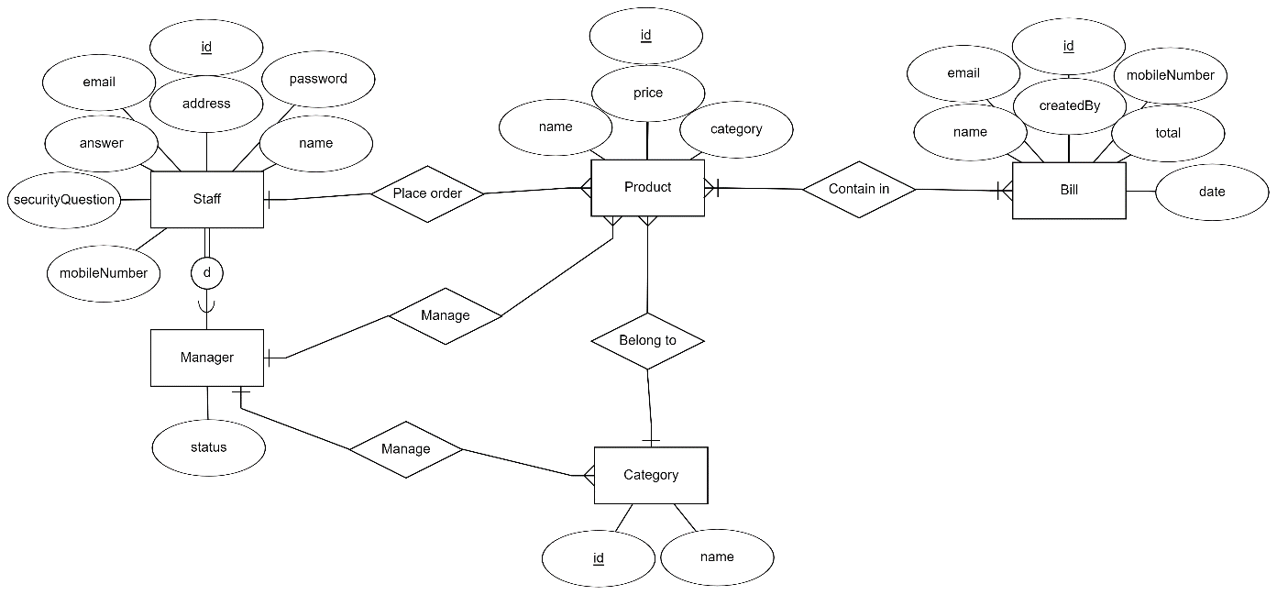

Figure 82: Entity-relationship diagram

1. 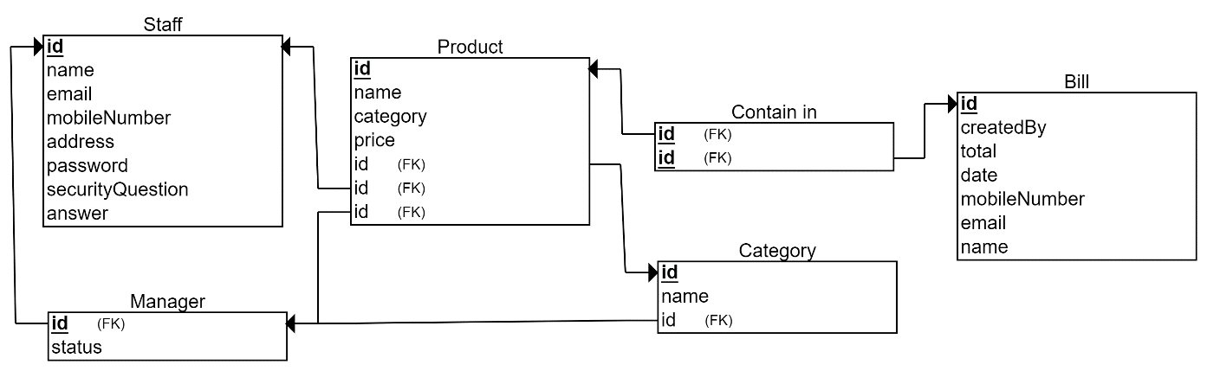Relationship Schema

Figure 83: Relationship schema diagram

e. Table design

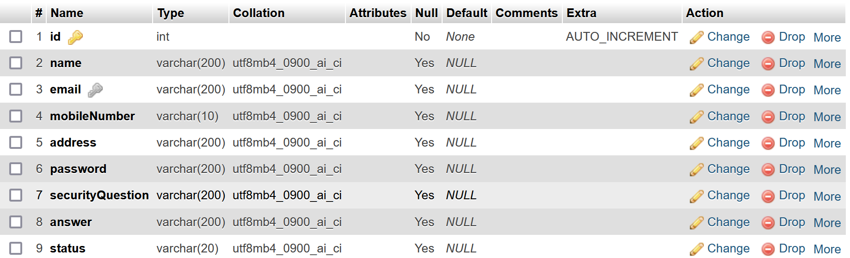

Figure 84: ‘User’ table

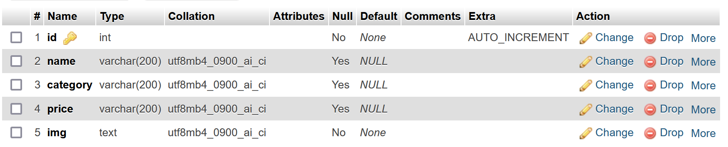

Figure 85: ‘Product’ table

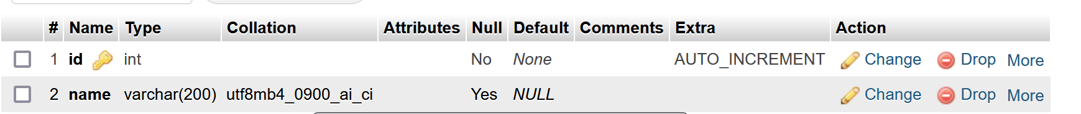

Figure 86: ‘Category’ table

Figure 87: ‘Bill’ table

2. Static model – class diagram

Figure 88: Class diagram

CHAPTER 6: DEMO CODE

1. Manager interface

Figure 89: Main screen

Figure 90: Login screen

Figure 91: Signup screen

Figure 92: Change Security Question screen

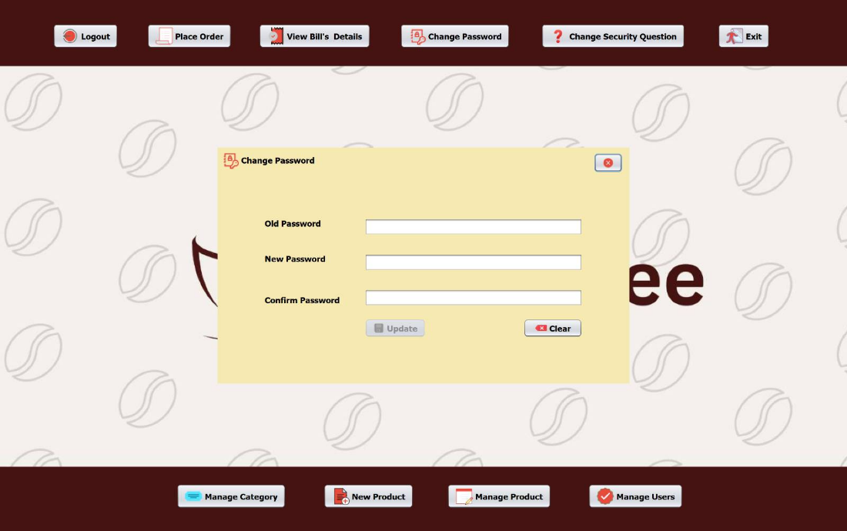

Figure 93: Change Password screen

Figure 94: View Bill’s Detail screen

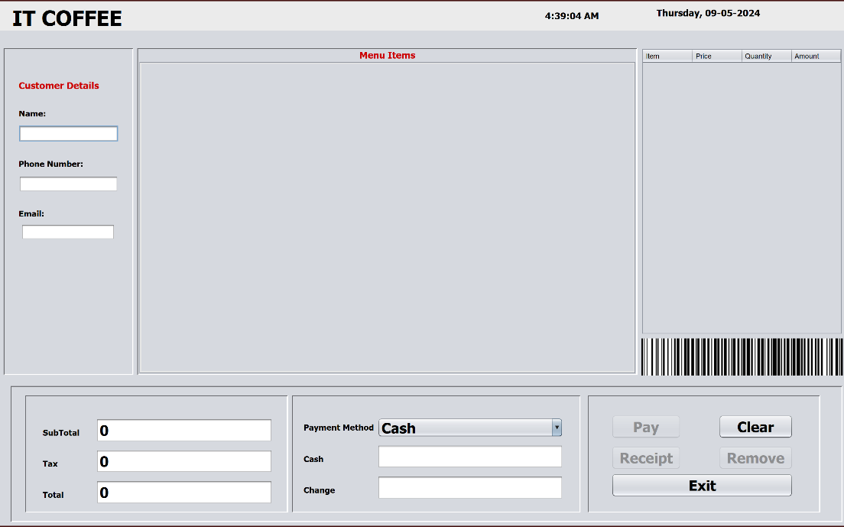

Figure 95: Place Order screen

Figure 96: Manage Users screen

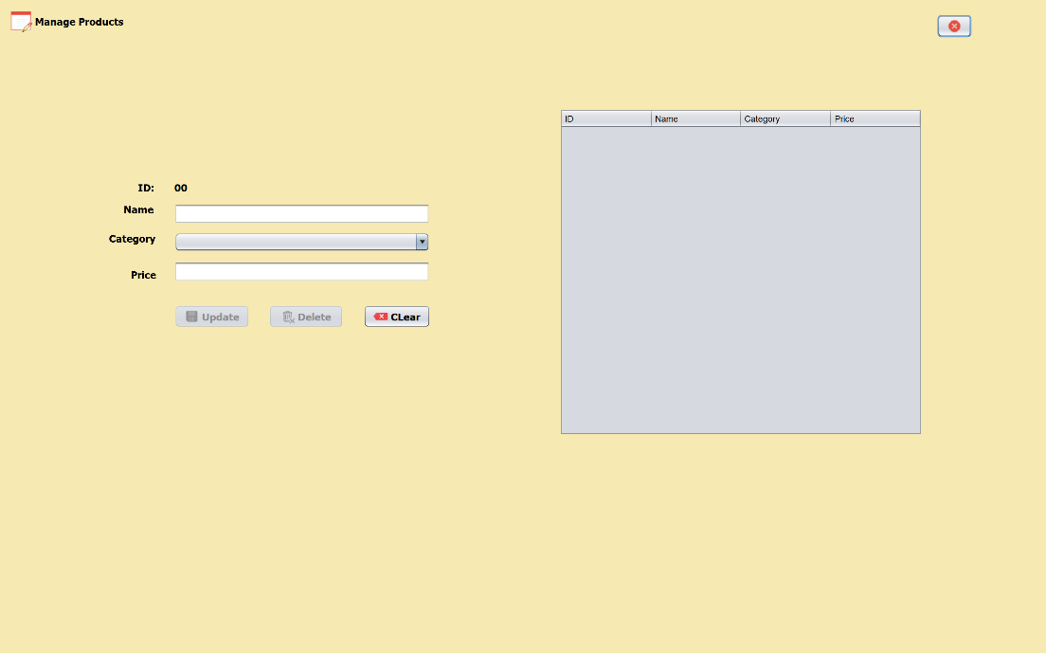

Figure 97: Manage Product screen

Figure 98: New Product screen

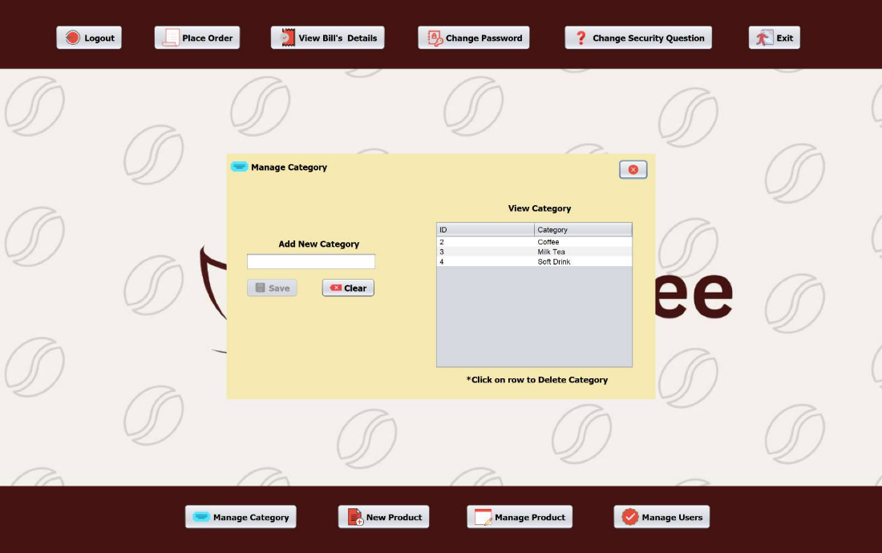

Figure 99: Manage Category screen

1. Staff interface

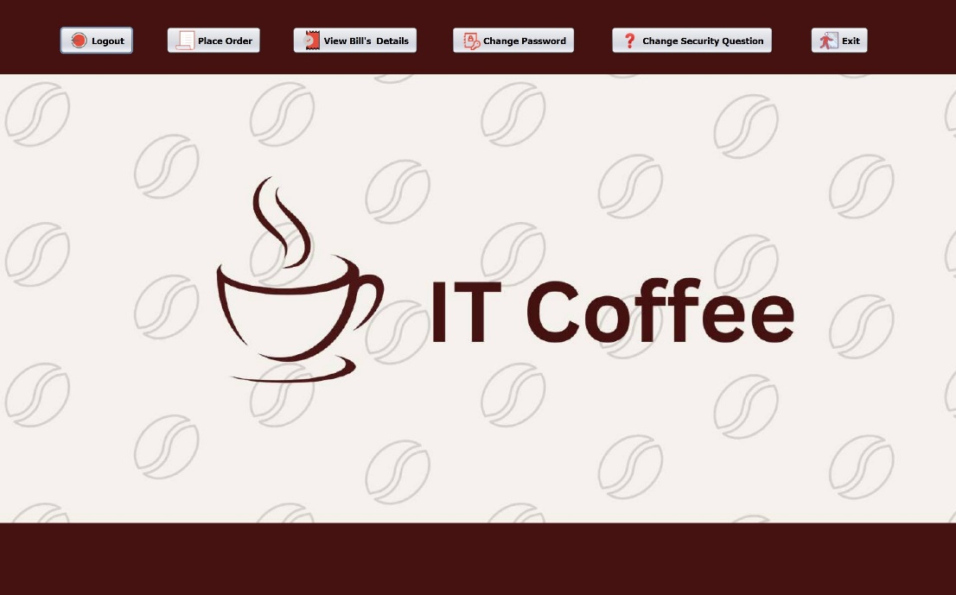

Figure 100: Main screen

CHAPTER 7: TEST PLAN

1. Requirements system level test cases

**Defining Test Completion Criteria**: Testing is completed only when all the functional and non-functional testing is complete.

**Design Test Cases:** Test case has five parameters call initial state, the input, data setup, expected outcomes and actual outcomes.

**Execute Tests:** Execute the test cases against the system under test and document the results.

**Verify Test Results:** Verify if expected and actual results match each other.

**Verify Test Coverage:** Verify if tests cover both functional and non-functional aspects of the requirement.

**Track and Manage Defects:** Any defects detected during the testing process goes through the defect life cycle and are tracked to resolution. Defect Statistics are maintained which will give us the overall status of the project.

1. Requirements system level test cases

Techniques used for test generation: **Error Guessing**

Technique based on guessing the error which can prevail in the code.

Heavily based on the experience where the test analysts use their experience to guess the problematic part of the testing app.

**Guidelines for Error Guessing:**

Test should use the previous experience of testing similar applications

Understanding of the system under test

Knowledge of typical implementation errors

Remember previously troubled areas

Evaluate data and Test results

1. Test results

|  |  |  |  |  |
| --- | --- | --- | --- | --- |
| ID | Items | Steps to execute | Expected output | Status |
| 0 | Login Page | Open System | System page displaying a login page | Success |
| 1 | Login Page | 1. Open system Enter things in Component | 1. System page displaying a login page  2. Displaying message "Incorrect Email or Password" | Success |
| 2 | Sign Up | Open System Go to "Sign Up" | " Signup" section displaying | Success |
| 3 | Create account validation | 1. Go to "Sign Up"  2. Enter all value in Components section  3. Clicks on "Save" | "Save" button is touchable Validation message displayed | Success |
| 4 | Create account validation | 1. Go to "Sign Up"  2. Enter all value in Components section  3. Enter >10 or <10number in mobile number  4. Clicks on "Save" button | Can press "Save" button No Validation message displayed | Fail |
| 5 | Create account validation | 1. Go to "Sign Up"  2. Enter all value in Components section  3. Enter mail without @Click on "Save" button | Can press "Save" button No Validation message displayed | Fail |
| 6 | Forgot Password | 1. Go to “Forgot password” | Forgot Password” page displaying | Success |
| 7 | Forgot Password | 1. Go to “Forgot password”  2. Enter “Email” in email component | 1. “Forgot Password” page displaying  2. “Search” button is available | Success |
| 8 | Forgot Password | 1. Go to “Forgot password”  2. Enter “Email” in email component without @ | 1. “Forgot Password” page displaying  2. “Search” button is unavailable | Success |
| 9 | Forgot Password Security Question | 1. Go to “Forgot password”  2. Enter “Email” and use search Button  3. Security question appear for account | Security Question appeared | Success |
| 10 | Forgot Password Security Question | 1. Go to “Forgot Password”  2. Enter “Email” and use search Button  3. Security question appear for account4. Answer question correctly  5. Enter your new password | Update button is available Update message displayed | Success |
| 11 | Forgot Password Security Question | 1. Go to “Forgot Password”  2. Enter “Email” and use search Button  3. Security question appear for account  4. Answer question wrongly5. Enter your new password | Update button is available Update message display Incorrect answer displayed | Fail |
| 12 | Login Staff account | 1. Login staff account | displaying staff UI | success |
| 13 | Staff account | 1. Login staff account  2. Have 4 components | 1. Displaying staff UI2. Displaying Placed Order3. Displaying “View Bill’s Details”  4. Displaying “Change Password” | Success |
| 14 | Place Order | 1. Go to “Place Order”  2. Enter all components | 1. Displaying “Place Order”  2. All components is all available | Success |
| 15 | Place Ordering | 1. Go to “Place Order”  2. Choose Name of products  3. Choose Category  4. “Product Name & Price & Total” is unwritable | 1. Displaying “Place Order”  2.Choose category for products  3. Click into Name will auto write “Price” and “Total” | Success |
| 16 | Add to Cart | 1. Go to “Place Order”  2. Write Customer details  3. Choose category  4. Choose your products  5. Add to cart | 1. Displaying “Place order”  2. Customer details is written  3. Choose category for products  4. Choose products name  5. Add to card | Success |
| 17 | Add to Cart | 1. Go to “Place Order”  2. Write Customer details  3. Choose category  4. Choose your products  5. Add to cart  6. Showing “Grand Total” | Displaying “Place order”  2. Customer details is written  3. Choose category for products  4. Choose products name  5. Add to card  6. Showing “Grand Total” | Success |
| 18 | Generating Bill & Print | 1. Go to “Place Order”  2. Write all components  3. Press “Generate Bill & Print” | 1. Displaying “Place Order”  2. All components is fulfill  3. Add to cart is available  4. Generated bill displaying a message box | Success |
| 19 | Generating Bill & Print | 1. Go to “Place Order”  2. Write All components  3. Don’t choose category  4. Press “Generate Bill & Print” | 1. Displaying “Place Order”  2. All components is fulfilled  3. Add to cart is available  4. Generated bill displaying a message box | Fail |
| 20 | Generating Bill & Print bill out | 1. Go to “Place Order”  2. Write all components  3. Don’t choose category  4. Press “Generate Bill & Print” | “Bill Details Add” message box displaying Print details in Word | Success |
| 21 | View Bill | 1. Go to “View Bill’s details” | System page is displaying “View bill” | Success |
| 22 | View Bill’s details | 1. Go to “View Bill’s details”  2. Choose correct components | System page is displaying “View bill - order by date” can’t change | Fail |
| 23 | View Bill’s details | 1. Go to “View Bill’s details”  2. Choose correct components | System page is displaying “view bill” Filter by date changeable | success |
| 24 | View Bill and Order Position | 1. Go to “View Bill’s details”  2. Choose change order by ID | Combo box is useable | Success |
| 25 | Change Password | 1. Go to “Change Password” | System displaying “Change Password” site | Success |
| 26 | Change Password | 1. Go to “Change Password”  2. Input old password3. Input new password | Message box about change password success | Success |
| 27 | Change Password | 1. Go to “Change Password”  2. Input old password  3. Input new Password same as old password | Message box about change password unsuccess | Fail |
| 28 | Change security Question | 1. Go to “Change security Question” | System displaying “Change security question” site | Success |
| 29 | Change security question | 1. Go to “Change security question”  2. all components are deployed | Message box about change security question successful | Success |
| 30 | Change security question | 1. Go to “Change security question”  2. Old security question is changeable | doesn’t displaying message box about change security question | Fail |
| 31 | Change security question | 1. Go to “Change security question”  2. Enter wrong password | Displaying message “Password is incorrect” | Success |
| 32 | Login manager account | 1. Go to Login site | Displaying Login site | success |
| 33 | Login manager account | 1. Go to Login site  2. Login manager account | Displaying Login site Displaying manager account | Success |
| 34 | Manager account | 1. Login manager account  2. Have manager function | adding 4 more functions for manager | Success |
| 35 | Manage Category | 1. Go to “Manage Category” | System displaying “Manage Category” Site | Success |
| 36 | Manage Category | 1. Go to “Manage Category”  2. Adding new category | Adding new category to list Save button is available | Success |
| 37 | New Product | 1. Go to “New Product” | System displaying “New Product” site | Success |
| 38 | New Product | 1. Go to “New Product”  2. Adding name  3. Choose category  4. Adding Price | Creating new product for choosing category | Success |
| 39 | New Product | 1. Go to “New Product”  2. Add number to name3. Choose category4. Adding price | Display message “Wrong product name” | Fail |
| 40 | New Product | 1. Go to “New Product”  2. Adding name  3. Choose category  4. Adding character to price | Display message “Wrong product price” | Fail |
| 41 | View Product | 1. Go to “Manage Product” | System displaying the site | Success |
| 42 | View Product | 1. Go to “Manage product”  2. Look at the table | table displaying product “ID, Name, Category, Price” | Success |
| 43 | Edit Product | 1. Go to “Manage product” | System displaying the site | Success |
| 44 | Edit Product | 1. Go to “Manage product”  2. Edit each compo in table | “ID, Name, Category, Price” is editable | Success |
| 45 | Edit Product | 1. Go to “Manage product”  2. Edit components in table | “ID, Name, Category, Price” attribute is unchangeable | Fail |
| 46 | Update Product | 1. Go to “Manage product”  2. Update products “Price and name” | System message box “Update product” success | Success |
| 47 | Update Product | 1. Go to “Manage product”  2. Update product Price with Char and Name with int | System message box “Update product unsuccess” | Fail |
| 48 | Delete Product | 1. Go to “Manage product” | System displaying update and delete site | Success |
| 49 | Delete Product | 1. Go to “Manage product”  2. Choose a product on table and delete | System displaying message box “Delete product success” and product delete from table | Success |
| 50 | Delete Product | 1. Go to “Manage product”  2. Choose a product on table and delete | System displaying message box “Delete product unsuccess” and product can’t delete from table | Fail |
| 51 | Verify User | 1. Go to “Manage user” | System displaying “Manage user” site | Success |
| 52 | Verify User | 1. Go to “Manage user”  2. Search for user  3. Click on row to change status | Displaying message box “Do you want to change status” | Success |
| 53 | Verify User validation | 1. Go to “Manage user”  2. Search for user  3. Click on row to change status  4. Yes for do question | Displaying message box “Status changed successfully” | Success |
| 54 | Verify user status | 1. Go to “Verify user”  2. Search for user  3. Validation change status  4. Status user change | User status changed from True to False or from False to True | Success |

Table 44: Test case and result.

**REFERENCE DOCUMENTS**

# 1. Cure 53. *Fine penetration tests for fine websites.* [Online] https://cure53.de/.

2. Test Plan (a Real Sample). *Software Testing Help.* [Online] https://www.softwaretestinghelp.com/wp-content/qa/uploads/2014/02/Live_Project_Test_Plan_SoftwareTestingHelp.pdf.

3. Class JFrame. *Oracle.* [Online] https://docs.oracle.com/javase/8/docs/api/javax/swing/JFrame.html.

4. Software Requirement Specification (SRS) Format. *GeeksforGeeks.* [Online] https://www.geeksforgeeks.org/software-requirement-specification-srs-format/.

5. Software Project Management Plan (SPMP) – Software Engineering. *GeeksforGeeks.* [Online] https://www.geeksforgeeks.org/software-engineering-software-project-management-plan-spmp/.